Porphyry Cu Geochemistry Workshop
Part 2 Alteration chemistry
Using 4 acid digest ICP analyses to map rock compositions, magmatic processes, and hydrothermal alteration.
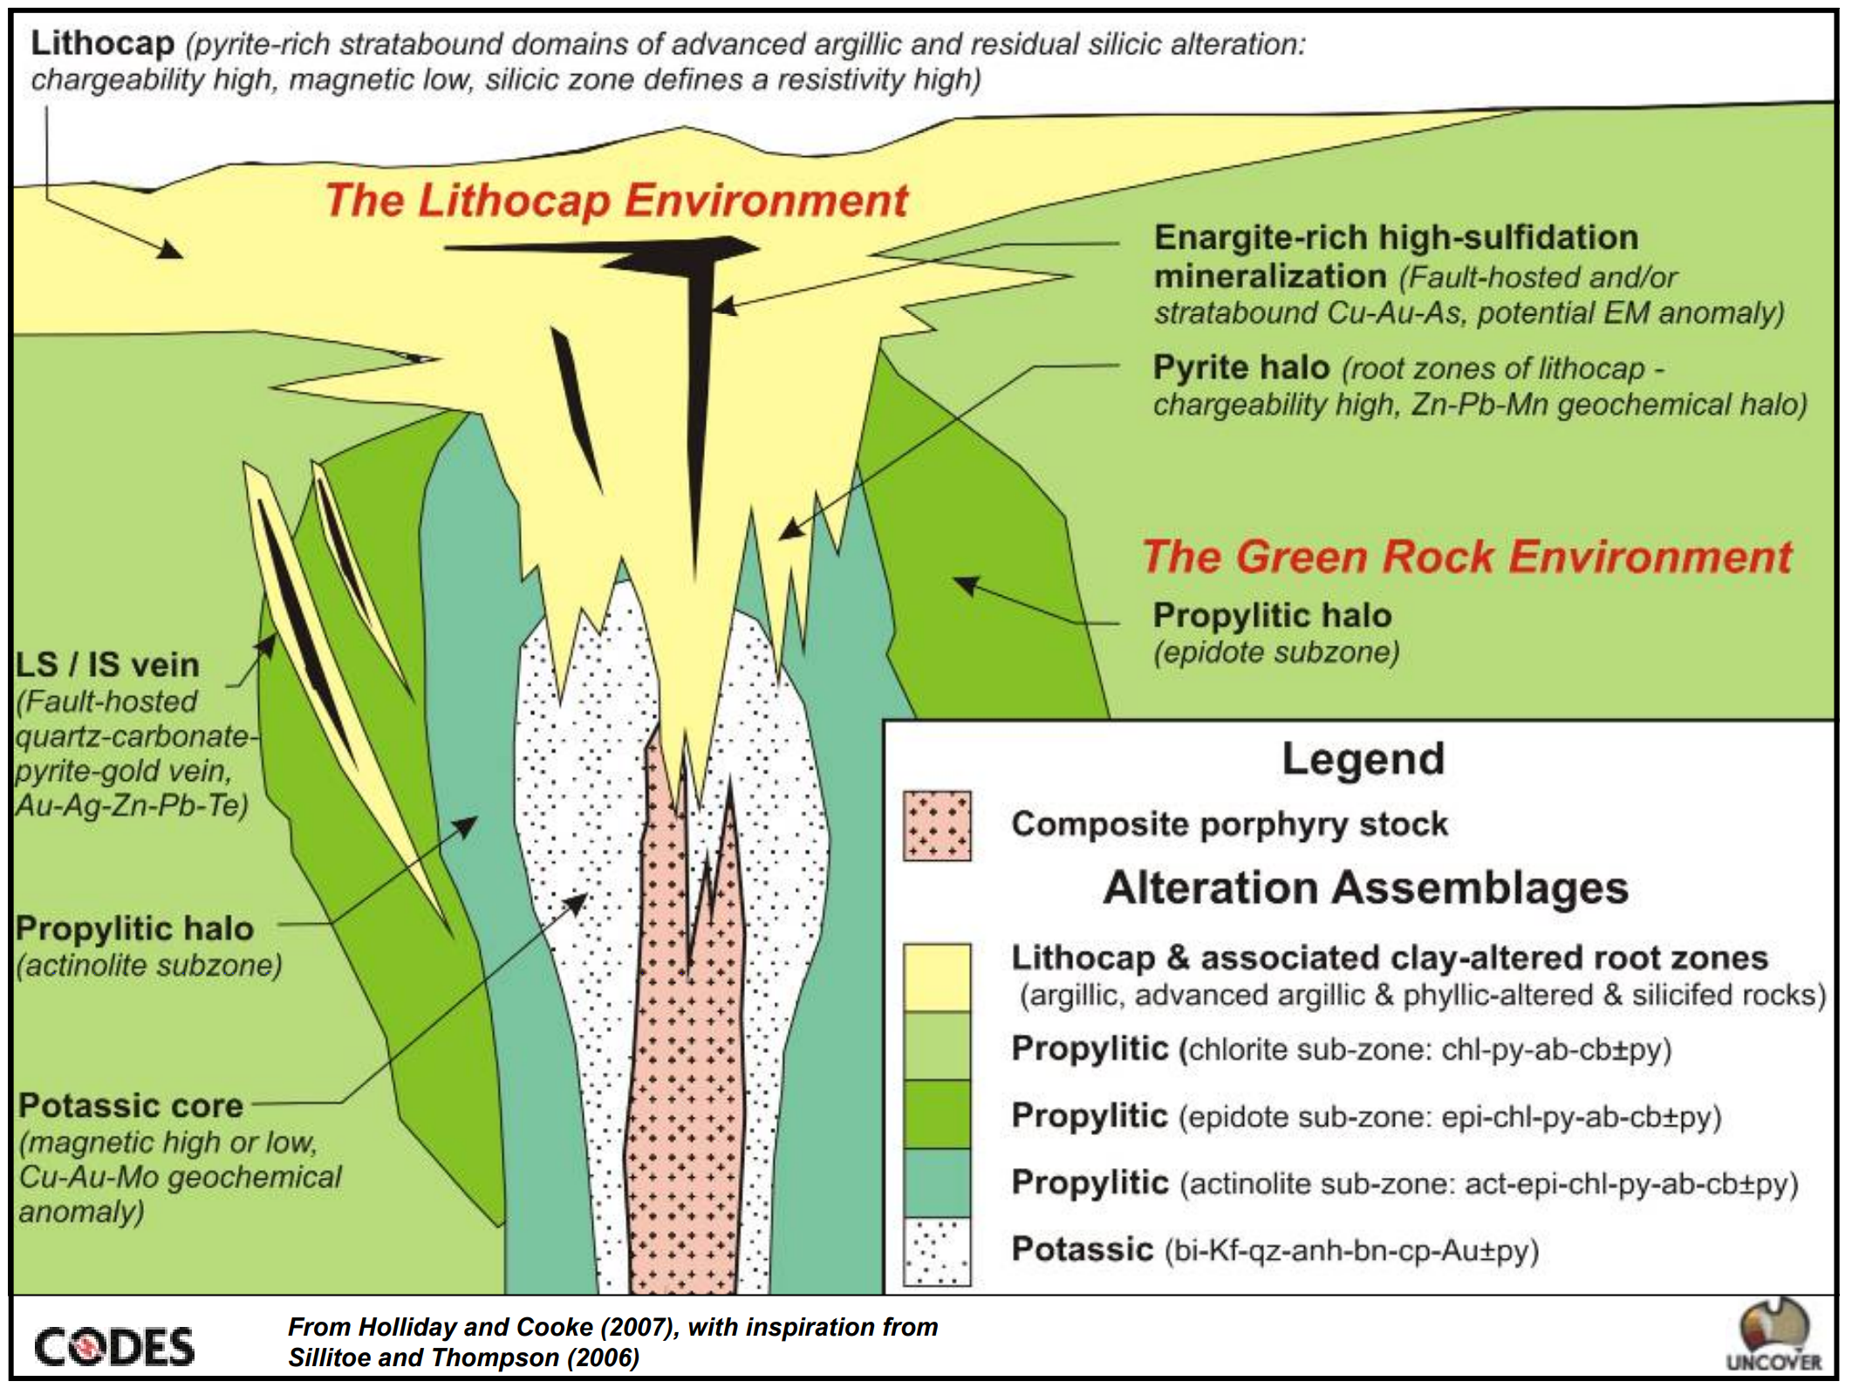

Scott Halley, 06/05/2021

Acknowledgments
The data for this tutorial was provided by Rio Tinto. The contribution of Rio Tint and especially the contribution of Chief Geochemist Phil Baker is gratefully acknowledged.
This is a subset of the drill hole analyses from a Rio Tinto porphyry copper prospect in the western USA. This deposit contains a broad spectrum of alteration types, including potassic, pervasive phyllic, advanced argillic, and a low temperature clay overprint. The idea of this workshop is that you should be able to follow the notes provided and replicate the interpretation process for yourself using ioGAS software.
It is difficult to consistently log hydrothermal alteration, particularly to achieve consistency between geologists. This tutorial shows how you can use plots of the major elements to recognize trends in data that relate to the distribution of common alteration minerals. This can be used as an aid to logging, or to directly construct more quantitative alteration models of mineral deposits.

Tracking Alteration from Major Element Chemistry.
This is a workflow to classify alteration.
- K/Al vs Na/Al molar ratio plot to map sericite alteration
- Al-K-Mg ternary plot to map relative proportions of sericite vs chlorite and biotite
- Ca-Fe-S ternary plot to map anhydrite
- Ca vs Mg to map calcite vs dolomite.
- Rb vs K to map alunite.
- Ca-K-Na to map feldspar compositions
- Fe vs S to map the degree of sulfidation

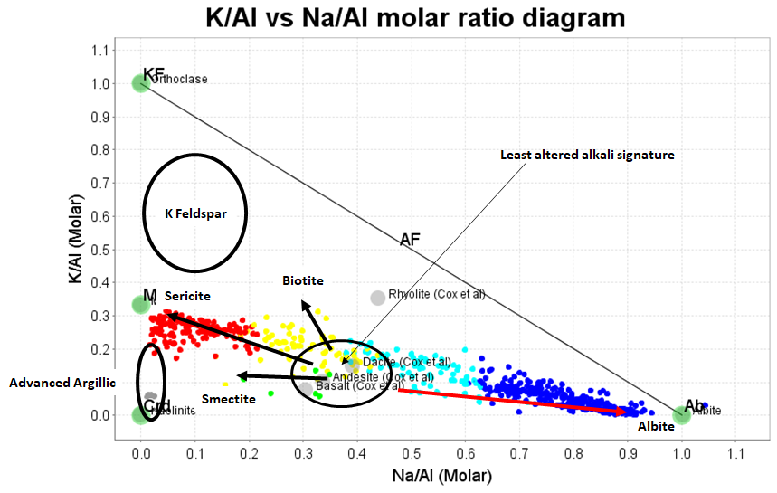
A useful way to characterize alteration in porphyry copper deposits is to plot K/Al versus Na/Al calculated on a molar basis. Consider a rock that is totally sericitized. The mineralogy of the rock might be muscovite-quartz-carbonate-pyrite. All the K and Al in that rock will be within sericite. Muscovite has a composition of KAl₃Si₃O₁₀(OH)₂. Therefore, the ratio of K:Al in the sericitized rock is 1:3. Similarly, a totally K feldspar (KAlSi₃O₈) altered rock will have a K:Al ratio of 1:1. In the same way, albitisation can also be tracked. Albite is NaAlSi₃O₈: Na:Al =1:1.
To pick alteration trends on this diagram it is necessary to make an educated guess as to where the least-altered version of each rock composition would plot on the diagram. Relative to the expected K and Na backgrounds for each compositional group, we can pick reactions towards albite, or muscovite. Advanced argillic alteration is strongly depleted in Na and to a lesser degree in K. Advanced argillic alteration typically has a halo of smectitic clays. Argillic alteration tends to be somewhat depleted in Na, but retains Ca and Mg. Biotite plots on a trend heading towards 1 on the K/Al axis, but the amount of K that is taken up in biotite is limited by the availability of Fe (ie the abundance of hornblende phenocrysts). Although we always talk about potassic alteration in porphyry Cu systems, it is uncommon to see volumetrically significant hydrothermal K feldspar in porphyry systems.
Figure 1. Porphyry Cu alteration zonation schematic.
The alteration signatures in porphyry Cu systems are diverse. The widely accepted conceptual model for porphyry systems can be quite misleading. Alteration signatures within the copper shells can include;
Proximal Alteration
- Feldspar-sulfides-sulfates; addition of anhydrite and sulfides with little or no change to the K and Na contents! This is probably the most common signature.
- Potassic; modest increase in K, hosted in biotite, through to intense K feldspar flooding.
- Sodic; widespread hydrothermal albite as the dominant feldspar type, along with biotite replacing hornblende. The extent of albite is commonly underestimated.
Peripheral and/or overprinting alteration types include;
- Phyllic; white mica plus pyrite +/- chlorite.
- Advanced Argillic; pyrophyllite, dickite or kaolinite +/- alunite, with intense pyrite.
- Argillic; low temperature smectite-illite-kaolinite-chlorite, usually with a low pyrite content, overprinting feldspar-bearing rocks especially potassic alteration.
- Sodic-Calcic; feldspar flooding with compositions from albite through to oligoclase, generally as a result of saline groundwater in the propylitic environment.
As an introduction to this workshop, I have provided examples from major porphyry deposits that show some of the variability in the whole rock chemistry reflecting the differences in mineral assemblages and alteration intensity that you should expect to encounter in porphyry Cu systems.

Alteration types in Porphyry Systems.

Feldspar-sulfides-sulfates

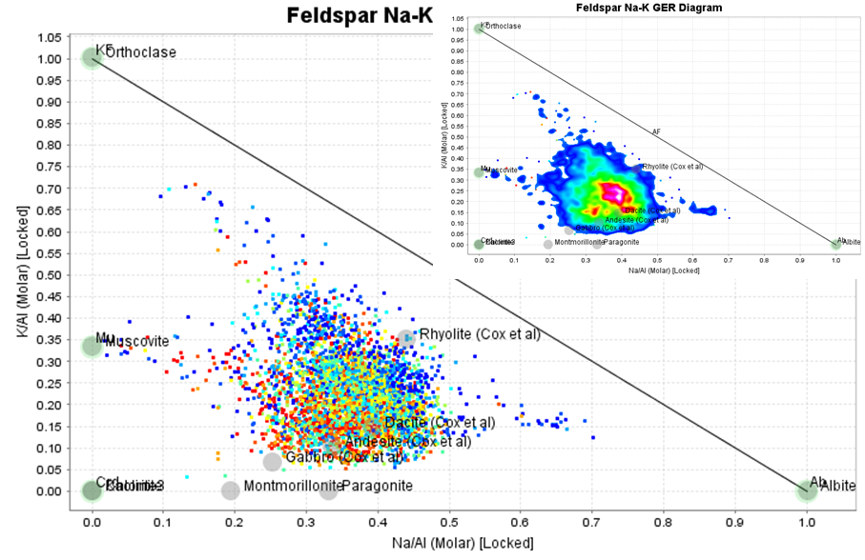
Figure 2. K/Al versus Na/Al (molar) from a porphyry system with very little addition or removal of K or Na.
This is a K/Al versus Na/Al molar ratio plot with data points coloured by 10 equal ranges of Cu grades. This deposit shows VERY MINOR variations in K and Na, due to primary lithological variations. Cu has been added to the rock without changing K or Na content. This is a surprisingly common pattern in porphyry Cu deposits!
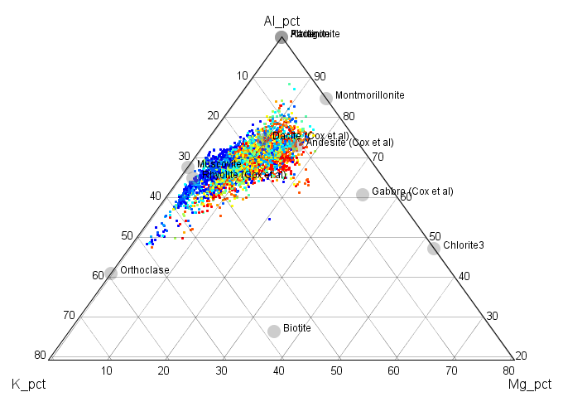
Figure 3. Al-K-Mg ternary plot. Same data as figure2.
This is the same data plotted on an Al-K-Mg ternary diagram. The variations in Mg are lithological, not hydrothermal.
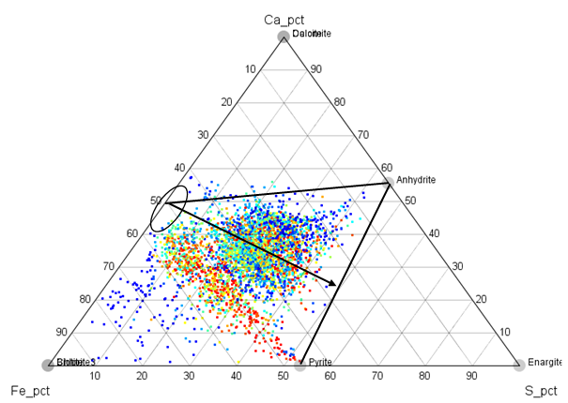
Figure 4. Ca-Fe-S ternary plot. Same data as figs 2 and 3.
This is the same data on a Ca-Fe-S ternary plot. The majority of unaltered igneous rocks plot on the Ca-Fe join, midway between the Ca and Fe apexes in the area shown by the ellipse. Samples do not plot above the join between these “least-altered” compositions and the anhydrite node unless they contain abundant carbonate. Similarly, samples should not plot on the S-rich side of the Anhydrite-Pyrite tie-line unless they contain alunite or abundant Cu sulfides such as chalcocite. The arrow shows the expected projection in compositions if the Ca and Fe contents (and K, Na and Mg) remain constant, but S is added to the rock. With the addition of S, calcic plagioclase was replaced by anhydrite, and hornblende was altered to chalcopyrite and pyrite. Most porphyry deposits have an anhydrite dissolution front. That can be seen in this data. If anhydrite is dissolved from mineralized samples, the dissolution trajectory takes the data directly away from the anhydrite node until all the sulfate is gone. With complete dissolution, the points remain on a line from the least-altered composition towards the pyrite node. The inference here is that all of the sodium from the primary plagioclase has been retained as albite.

Potassic
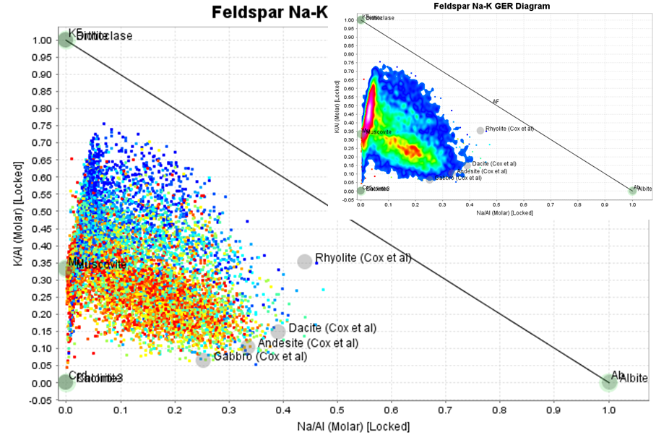
Figure 5. K/Al versus Na/Al (molar) from a porphyry system with intense K feldspar alteration.
Figure 5 is a K/Al versus Na/Al molar ratio plot with data points coloured by 10 equal ranges of Cu grades. The point density contour inset shows that most of the data is a mixture of muscovite with a potassic mineral; either orthoclase or biotite. Note that most of the Cu is not with the intense K feldspar.
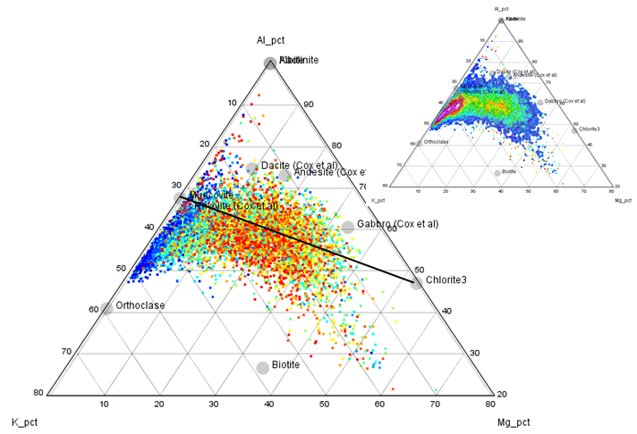
Figure 6. Al-K-Mg ternary plot. Same data as figure 5.
On the Al-K-Mg ternary plot (fig 6) samples plotting on the K-rich side of the muscovite-chlorite join must contain either orthoclase or biotite. There is clearly a trend towards orthoclase, which is poorly mineralized, and another broad cloud of biotite-bearing samples which is associated with mineralization.
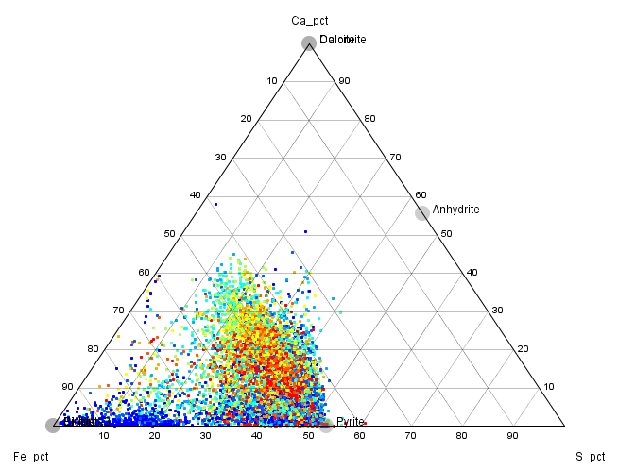
Figure 7. Ca-Fe-S ternary plot. Same data as figs 5 and 6.
The Ca-Fe-S ternary plot shows that this very potassic alteration system does not contain anhydrite. Very K-rich systems tend to have less anhydrite.

Sodic.
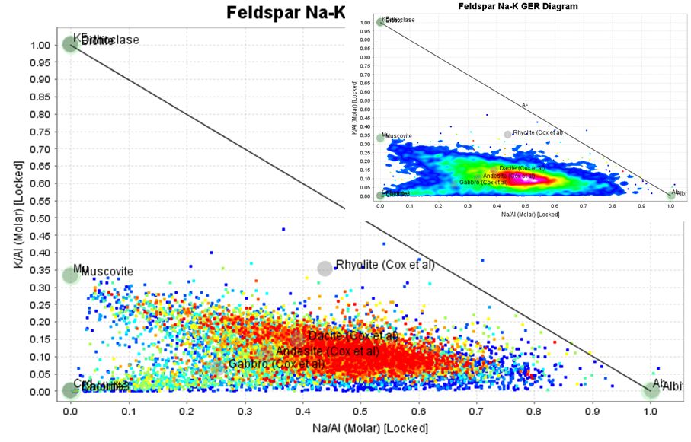
Figure 8. K/Al versus Na/Al (molar) from a strongly sodic porphyry system.
In figure 8, the node of compositions on the K/Al vs Na/Al molar ratio plot is significantly more sodic than typical andesitic to dacitic compositions. Note also that few of the data points plot above the muscovite to albite tie-line. In some sodic systems, the compositions plot closer to the albite-orthoclase tie-line.
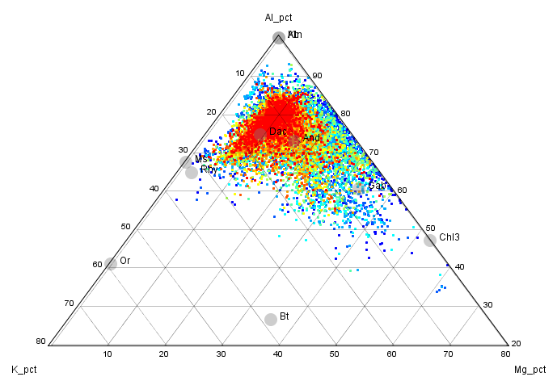
Figure 9. Al-K-Mg ternary plot. Same data as figure 8.
Although there are very few points plotting on the biotite-rich side of the muscovite-chlorite tie-line, there is still a small amount of biotite associated with copper sulfides in these rocks.
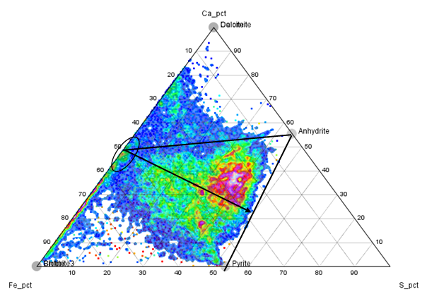
Figure 10. Ca-Fe-S ternary plot. Same data as figs 8 and 9.
Figure 10 shows rocks contain abundant anhydrite, and the data points are approaching the anhydrite-pyrite tie-line. In these rocks, all of the calcic plagioclase is replaced by anhydrite, K from primary orthoclase has gone into biotite and sodium has been added to the rock to form extra albite.

Phyllic.
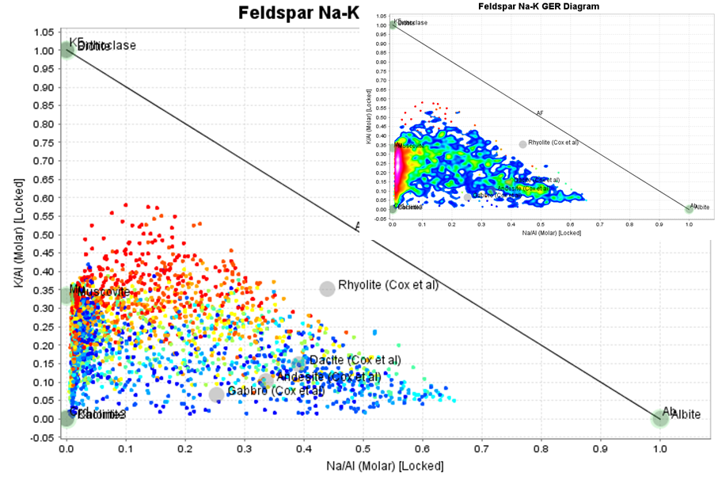
Figure 11. K/Al versus Na/Al (molar) from a porphyry system with intense phyllic alteration.
Figure 11 shows very intense Na depletion with most of the data points plotting at the muscovite node, and below towards the advanced argillic node. Most of the grade is associated with intense phyllic alteration.
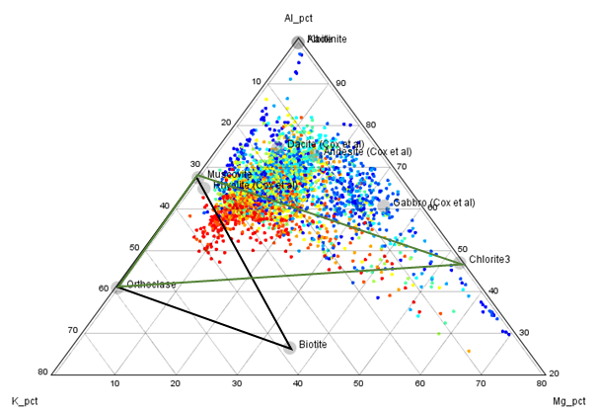
Figure 12. Al-K-Mg ternary plot. Same data as figure 11.
Mg was not depleted from these rocks by the intense sericitisation. It is not apparent from this diagram, but in this case, Mg was retained in a dolomitic carbonate. Normally with such intense sericitization, Mg would be depleted.
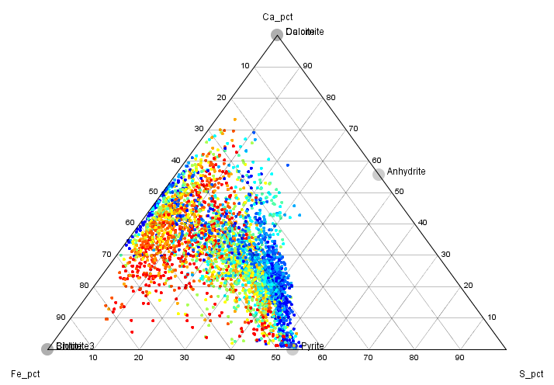
Figure 13. Ca-Fe-S ternary plot. Same data as figs 11 and 12.
The Ca-Fe-S ternary plot (fig 13) shows that this system has no anhydrite. Not many porphyry systems contain carbonates. In those that do, there is a competition between carbonate and sulfate for the Ca. Carbonates win.

Advanced Argillic.
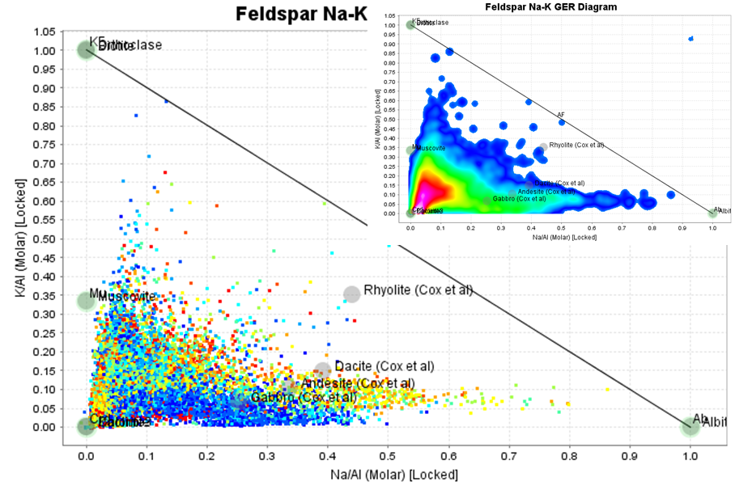
Figure 14. K/Al versus Na/Al (molar) from a porphyry system with intense advanced alteration. Note in the inset the proportion of points plotting near the origin.
In this plot, most of the data plots towards the origin, depleted in both Na and K.
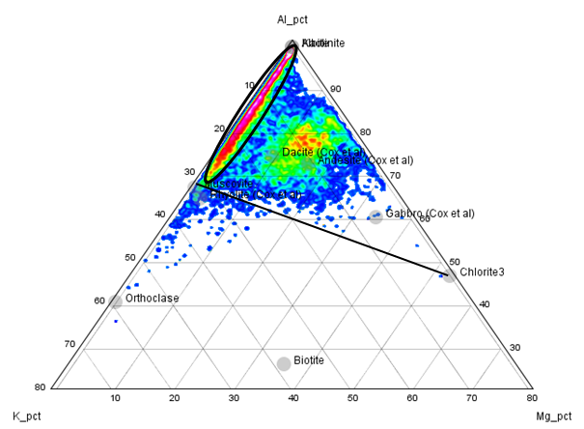
Figure 15. Al-K-Mg ternary plot. Same data as figure 14.
Figure 15 shows a very typical pattern for systems with a strong advanced argillic overprint. The data points have low Na and K, but on this ternary plot, they lie along the K-Al join, between the muscovite node and the Al apex, with no Mg.
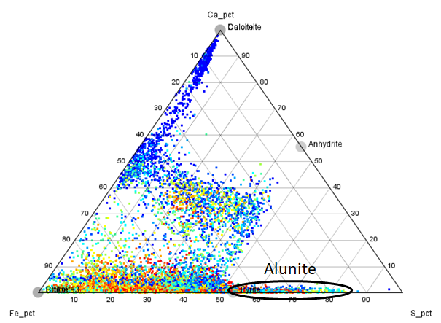
Figure 16. Ca-Fe-S ternary plot. Same data as figs 14 and 15.
In figure 16, there is a cluster of points that have no Ca, and lie on the Fe-S join on the S-rich side of the pyrite node. These samples contain alunite. The alunite-bearing samples are the reason why there more of the data does not plot at the origin on the K/Al versus Na/Al molar ratio plot (fig 14).

Argillic.
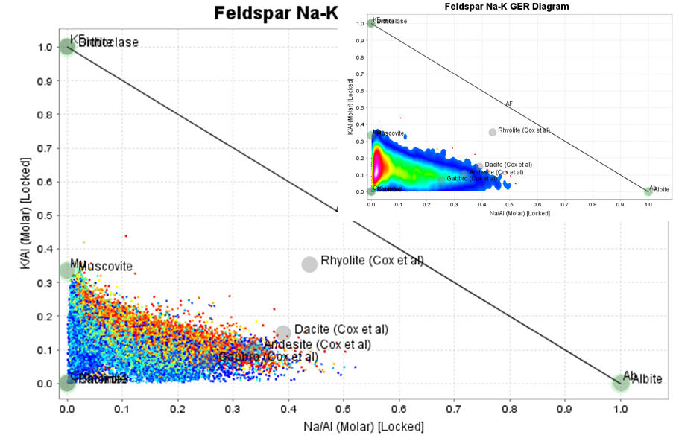
Figure 17. K/Al versus Na/Al (molar) from a porphyry system with intense intermediate-argillic overprint (illite-smectite-chlorite-kaolinite).
This is a porphyry system with a very intense argillic overprint. Hydrothermal feldspars are highly susceptible to hydrolysis reactions. In every potassic zone, feldspars appear turbid (cloudy) in this section, and in many cases, this becomes more than just a dusting of clays. These clays are probably combinations of illite, smectite, kaolinite and low temperature interlayed chlorite (SCC). In this example, the SCC has totally overprinted the rock. Note that the data points do not cluster towards the origin, as they would with advanced argillic alteration. The center of the cluster is between the muscovite and kaolinite nodes.
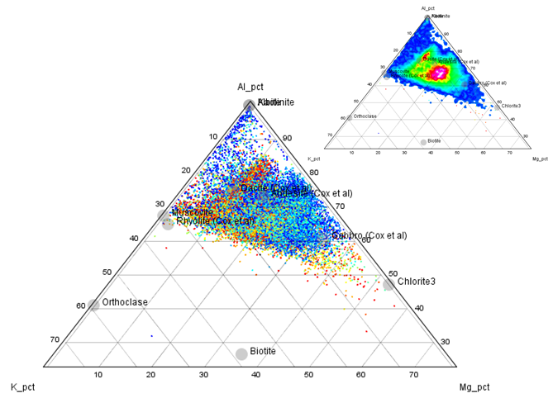
Figure 18. Al-K-Mg ternary plot. Same data as figure 17.
Although the clay alteration is strongly depleted in Na and has low K, it can easily be differentiated from advanced argillic alteration on the Al-K-Mg plot because the rocks are NOT depleted in Mg.
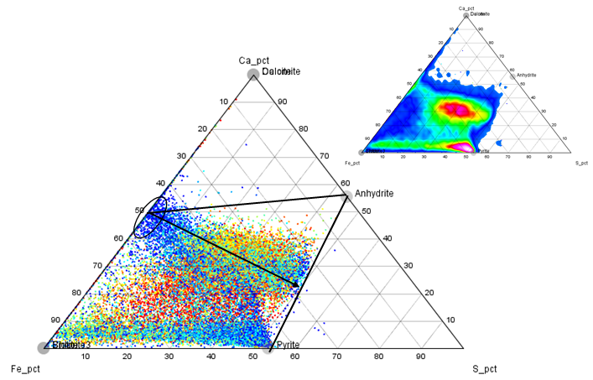
Figure 19. Ca-Fe-S ternary plot. Same data as figs 17 and 18.
In this particular example, there is abundant anhydrite, and also the typical anhydrite dissolution front. In this case, where the anhydrite is dissolved, there is no relict plagioclase (calcic or sodic), so the sulfate-leached samples plot at the pyrite node and back towards the Fe apex.

Classifying Mineralogy from Major Elements
Open the Alteration Exercise.gas file. The data points are already coloured by lithology compositions. This data includes 2 different porphyries which have intruded into a siliciclastic sedimentary sequence. In addition, there are 2 volumetrically minor types of intermediate dikes.
Go to Diagram, Provided, Element Ratio (GER), Feldspar, Feldspar Na-K Control Diagram. This will generate a K/Al versus Na/Al molar ratio plot.
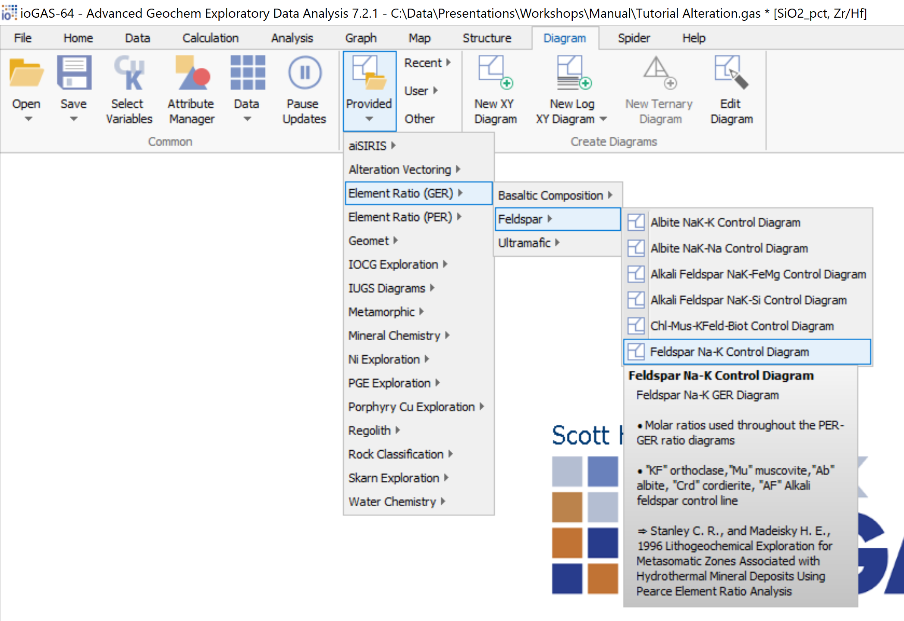

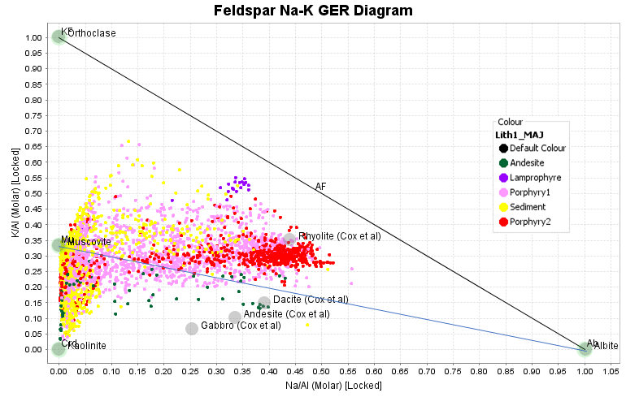
Add some Mineral and Rock compositions to this diagram to help visualize backgrounds and alteration trends. On the right-hand toolbar, click on Show Mineral and Rock Nodes. Then click on Mineral and Rock Node settings. You might need to Clear All Minerals first. Then go to Sheet Silicates tab. Turn on Muscovite and Biotite. Go to the Feldspar tab. Turn on Orthoclase and Albite. Go to the Rocks Tab, the Cox et al tab. Turn on Basalt, Andesite, Dacite, Rhyolite.
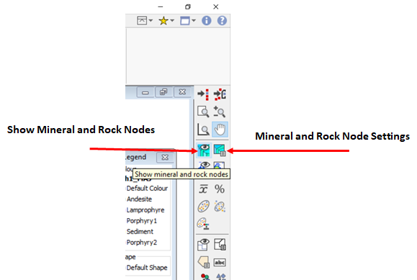
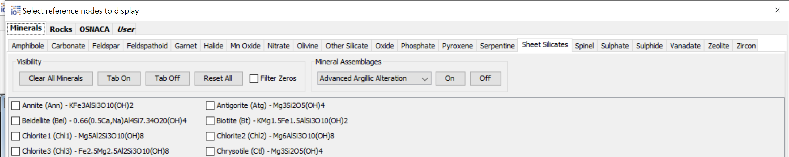
Imagine a tie-line from the Muscovite node to the Albite node. Samples that plot above this line must contain a potassium mineral that has a higher K/Al ratio than muscovite. This will be either orthoclase or biotite. Note that Porphyry2 plots as a very tight cluster on this diagram. It has had little or no addition or removal of K and Na. Porphyry1 is extensively altered. Most of the data points are trending towards muscovite, but some are more potassic than this and must have extensive addition of orthoclase and/or biotite. Some of the sediments also have strong potassic alteration. There is a strong cluster of data points plotting around the Muscovite node. This is most likely intense phyllic alteration. There is also a strong trend of points that are intensely Na-depleted, but plot with K/Al ratios less than muscovite. These samples contain Al-silicates than lack K. These could be advanced argillic clays or chlorite. We will need to use an Al-K-Mg ternary plot to resolve that.
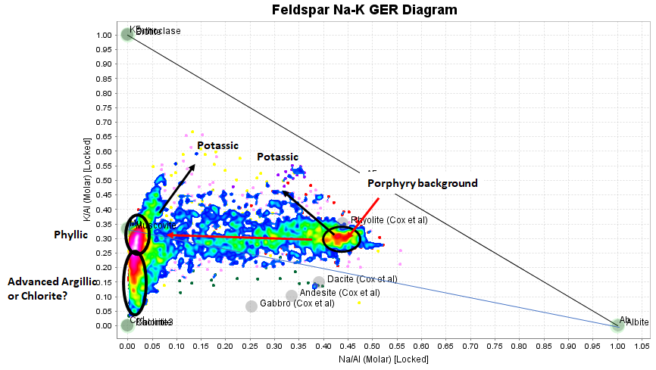
Looking at Porphyry1 and Porphyry2 in the K/Al vs Na/Al plot, it seems there is a lot more going on in Porphyry1. Let’s check this. From the list of variables, select Cu. Make a Split Probability plot. These plots can be toggled from N-Score on the x axis to Cumulative Frequency, which is easier the understand. Clearly most of the metal in in Porphyry1, and Porphyry2 is poorly mineralized.
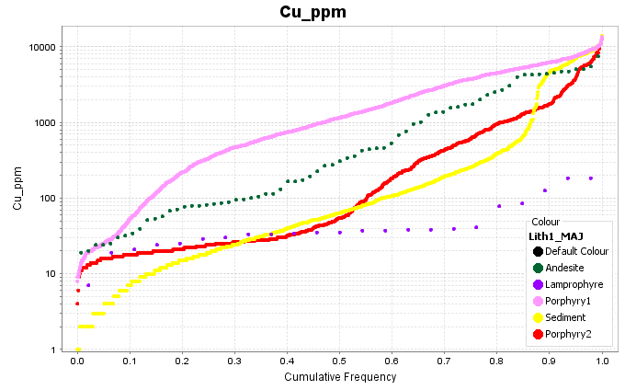
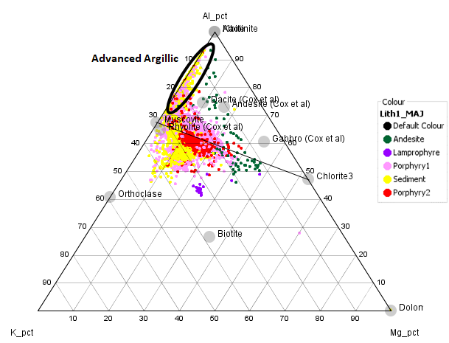
From the Al-K-Mg ternary plot, samples that plot on the K-rich side of the tie-line between chlorite and muscovite must contain orthoclase and/or biotite. The more Mg in these samples, the more likely it is that the K rich phase will be biotite. Samples that plot on the K-Al join between the muscovite node and the Al apex will have advanced argillic alteration.
Next select Ca, Fe and S, and make a ternary plot. The majority of unaltered igneous rocks will plot on the Ca-Fe join, midway between the Ca and Fe apexes. Samples should not plot above the join between these “least-altered” compositions and the anhydrite node unless they contain abundant carbonate. Similarly, samples should not plot on the S-rich side of the Anhydrite-Pyrite tie-line unless they contain alunite or abundant Cu sulfides such as chalcocite.
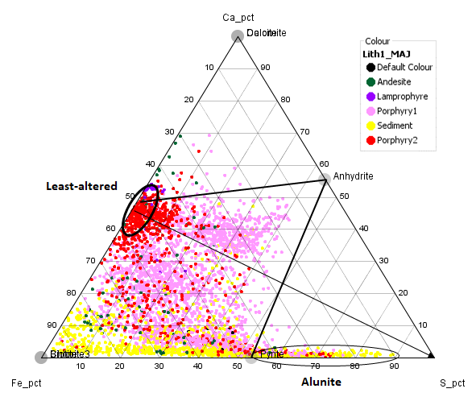
Draw a tieline from the least altered position towards the S apex. The cluster of Porphyry1 samples above this line almost certainly contains anhydrite.
From the list of variables, select K and Rb. Make an Xy plot. The samples that contain K but no Rb will contain alunite. The data supplied in this exercise is a mixture of ICP-MS and ICP-AES. The AES suite does not report Rb, so we will have to rely on the Ca-Fe-S plot to pick the alunite group.
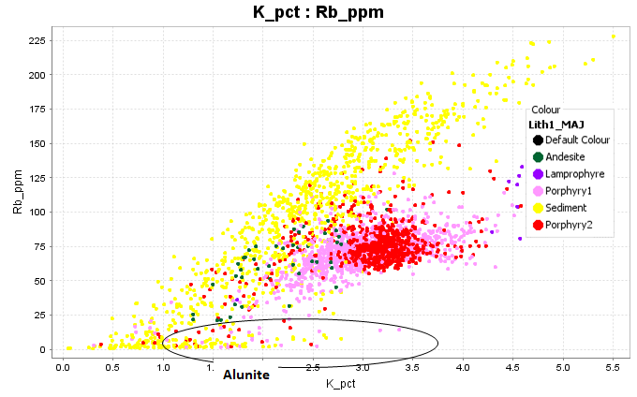
We are now going to delete the colours and create a new set of colours to describe the mineralogy. In ioGAS, save a checkpoint in case you need to undo any operations. In the Attribute Manager, delete all the colours. Add a new group, make it magenta and name it alunite. In the Ca-Fe-S ternary plot, select the samples that plot along the Fe-S join on the S-rich side of the pyrite node. Compare these with the K-Rb scatterplot. Some of the magenta samples DO contain Rb. These will be samples where the mineral with extra S is something like chalcocite rather than alunite. Note also that there are some black points with low Rb. These are probably samples with alunite, but where some of the S has been removed by oxidation of pyrite.

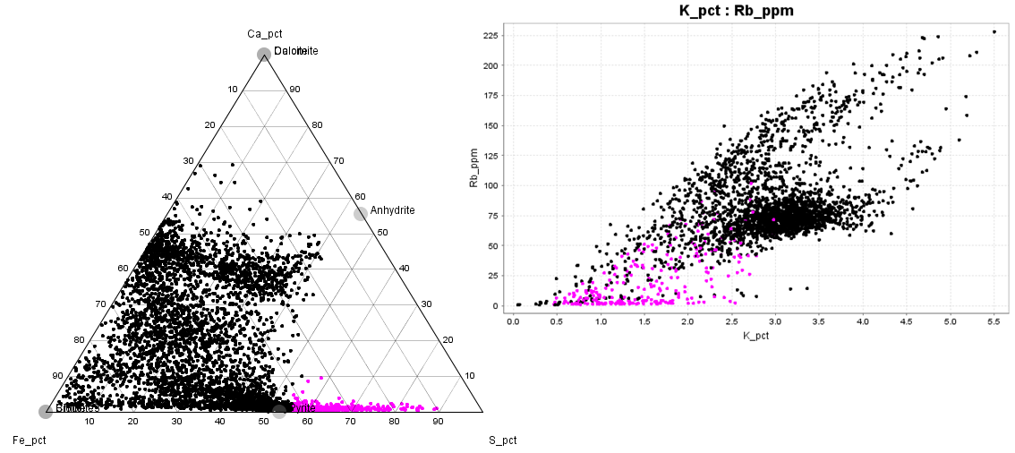

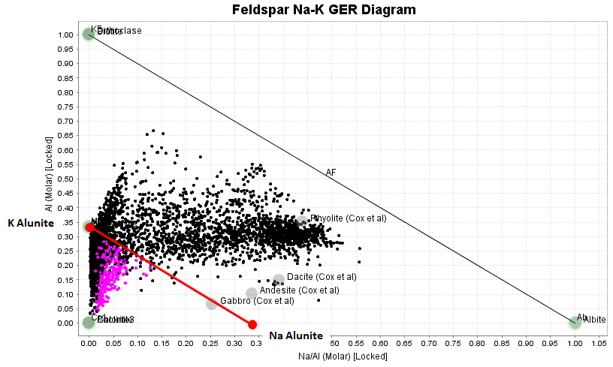
Have a look where the alunite samples plot on the K/Al vs Na/Al molar ratio plot. They plot in a triangle defined by K alunite, Na alunite and the origin point (pyrophyllite or dickite). These samples are mixtures of k-rich alunite and an aluminosilicate.
Turn off the Alunite group. Add a new colour group. Make it pink and name it Advanced Argillic. On the K/Al vs Na/Al molar ratio plot, select the samples that are depleted in Na and plot below around 0.25 K/Al. This is a bit arbitrary, but these samples must have an extra Al-phyllosilicate.
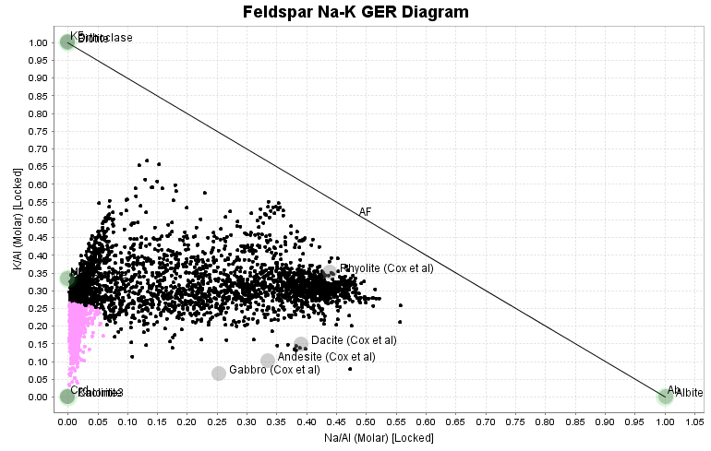
We now need to check whether this extra phyllosilicate is pyrophyllite/dickite or chlorite. Do this on the Al-K-Mg ternary plot. On the ternary diagram, some of the pink points plot on the Al-K join with no Mg. These will be genuine advanced argillic alteration. Some contain a significant amount of Mg. These are samples where ALL of the feldspar has been destroyed (no Na), and are now a mixture of sericite and chlorite. Turn off the black points, add a new colour group, make it green and name it sericite-chlorite and select the Mg-bearing, Na-depleted samples.
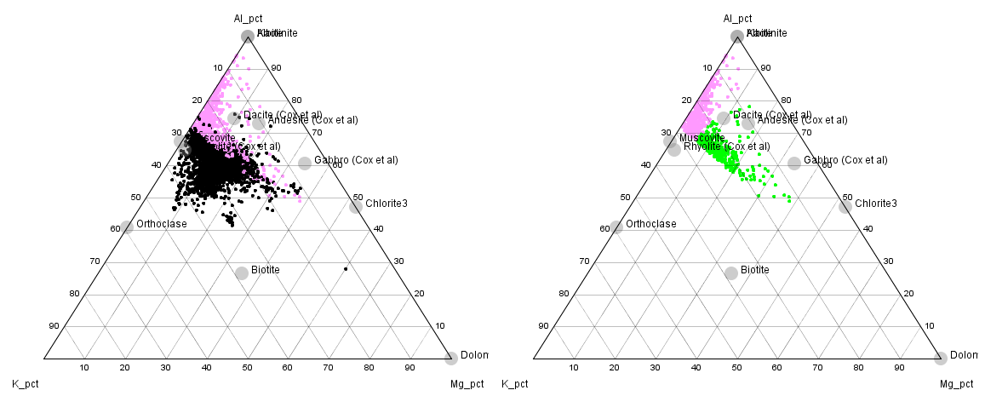
Turn off the Advanced Argillic and Sericite-Chlorite groups. Turn the black points back on. Add a new colour group. Call it Sericite and make it yellow. On the K/Al versus Na/Al molar ratio plot, select the samples that are strongly Na depleted and plotting with K/Al from 0.25 to around 0.4. These samples have intense phyllic alteration.
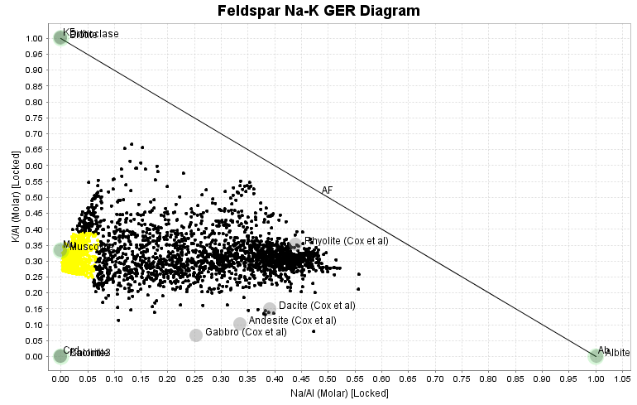

Next, turn off the yellow group of intense phyllic alteration. We have a good guide from the relatively unaltered compositions of Porphyry2 as to the background K and Na contents of the intrusions. We can pick a line above the K/Al values of unaltered intrusions across to the Y axis above muscovite compositions and select the samples with significant potassium addition. Select these samples as a new colour group, and name them potassic.
From the least altered porphyry compositions across towards the muscovite node, there is a trend of Na-depletion as those rocks become increasingly sericite-altered. Pick that trend as a new colour group, and name the group Moderate Phyllic alteration.
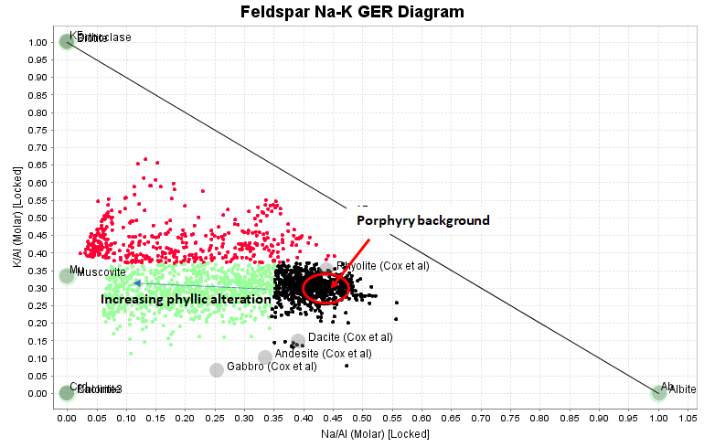
Now turn off all the colour groups except for the black points. Go to the Ca-Fe-S ternary diagram. Some of these unassigned points plot near 50:50 on the Ca-Fe join. These samples are the unaltered rocks. Make a new colour group. Make it grey and call it Unaltered as shown below. Make another new colour group. Make it orange and call it Feldspar-Sulfide-Sulfate, as shown below. In these samples, the K, Na, Mg and Fe contents have NOT changed significantly but they have a strong increase in S content. These samples will have abundant anhydrite as well as chalcopyrite and pyrite. It should also be noted that since they contain anhydrite, the primary plagioclase must be altered. The Ca from the plagioclase has gone into anhydrite and the remaining feldspar must now be more albitic. It is also likely in these samples that the primary hornblende has been altered to biotite, but the potassium in the biotite probably came from primary orthoclase.
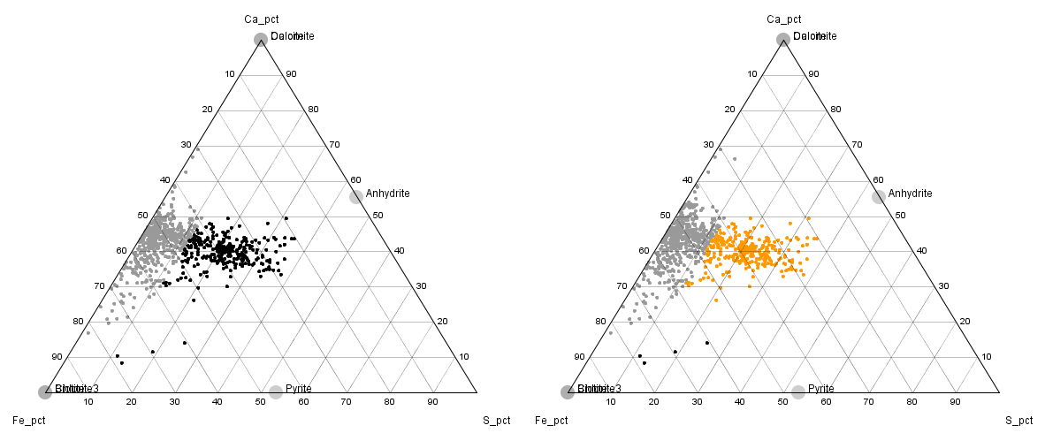

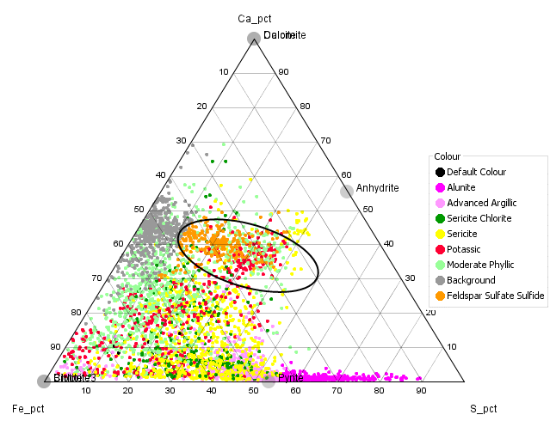
Now turn all of the colour groups back on. In the Ca-Fe-S ternary plot, note the overlap of the orange group and some of the pale green. This shows that I put the boundary of the moderate phyllic alteration in the wrong place on the K/Al versus Na/Al plot. We can reassign the green points as orange within the ellipse.
We can now see how this mineralogy classification looks in 3D space. Note the distal K feldspar!
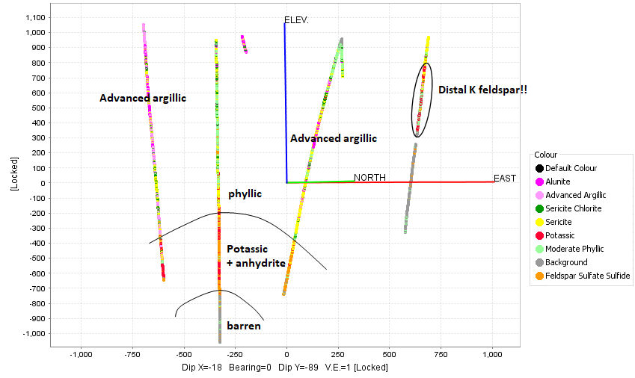

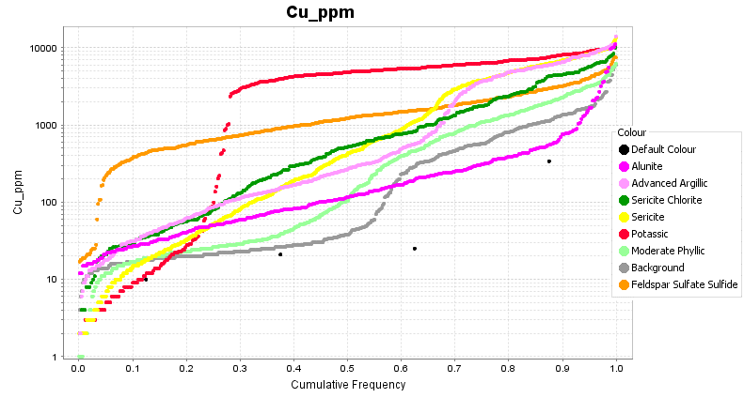
Make a split cumulative frequency plot for Cu to see which mineral zones are best mineralized. Note the higher grade Cu with the potassic zone, but the low grade tail, which is the distal K feldspar. There is also some significant grade with the sericite and advanced argillic alteration. I wonder if this is supergene Cu enrichment with supergene kaolinite, or a hypogene upgrading. The anhydrite zone has uniform low-grade mineralization.
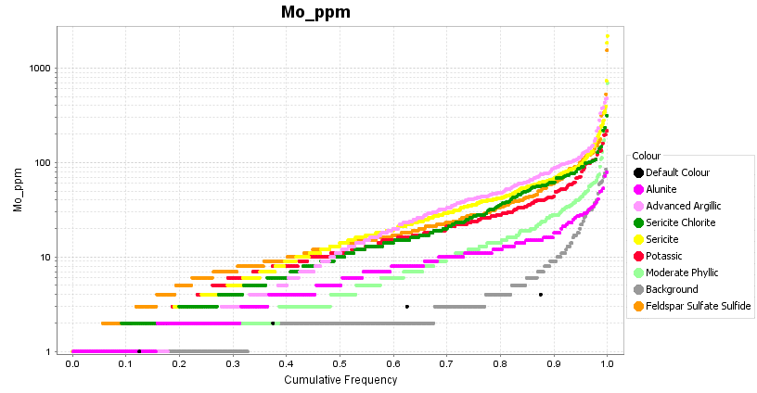
Make a split cumulative frequency plot for Mo. Mo has precipitated in proximal phyllic and advanced argillic alteration but not so much with the potassic.
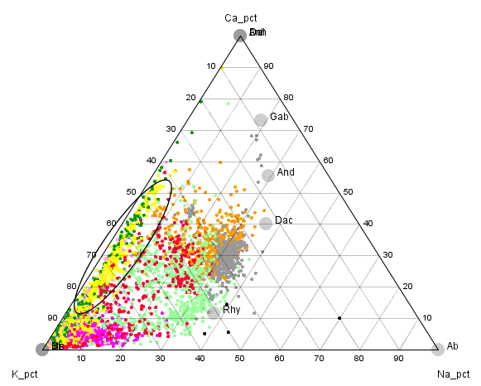
Make a ternary plot of Ca-K-Na. The yellow points have intense phyllic alteration with no remaining feldspar. However many of these points still retain Ca. That Ca could be either anhydrite or carbonate. This would be something worth checking as it could have significance for influencing flotation characteristics (pH control) and it could have acid neutralizing potential in waste rock dumps.
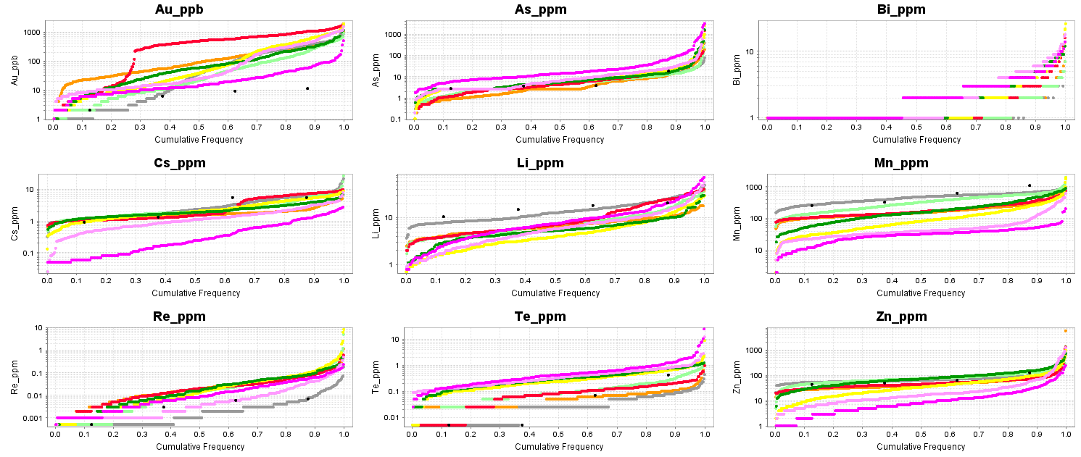
Make split cumulative frequency plots for other pathfinder elements to see which metals are enriched and which are depleted in various gangue mineral zones. You could also try colouring the data points by 10 equal ranges of pathfinder metal values to see where the metal-bearing samples fall on the alteration plots and in 3D space. To do this, go to the Attribute Manager and select one of the metals as the Colour variable, select 10 equal ranges, select a linear colour scale, then Auto-Attribute. (Be sure to save the file, or save a checkpoint first). Look for the Cu, Mo, Bi, Te, As, Cs-Li zoning pattern. Note that some of the assays were done just by ICP-AES therefore have significantly higher detection limits for Bi, Te and Sb especially. You could set up a filter based on the assay method, turn off the ICP-AES samples and just look at the data with good detection limits.
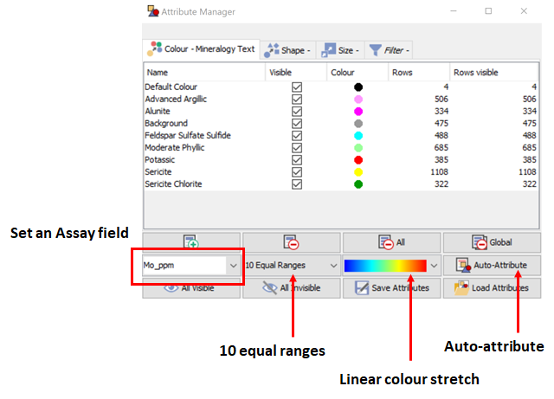
Another way to investigate the links between silicate mineralogy and pathfinders is to colour the data points by 10 equal colour ranges based on pathfinder contents. You can then see where the pathfinders plot on the alteration diagrams (eg K/Al vs Na/Al, Al-K-Mg ternary, Ca-Fe-S ternary), and you can see where the metals plot spatially on the section. Try this for Mo, Te, As and Mn. After that you can return to your alteration classification by Restoring the Checkpoint.

