Porphyry Cu Geochemistry Workshop
Part 4 Calculating Modal Mineralogy

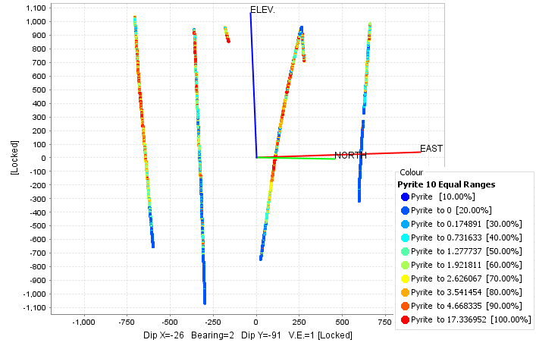

Scott Halley, 14/05/2021

Module 4: Modal Mineralogy calculations from whole rock geochemistry.

The objective of this exercise is to treat the assay data in a method that is more amenable to modelling in 3D, and to look at the data in a quantitative way rather than descriptive categories. Consider the reasons why we log hydrothermal alteration in drill core. At the exploration stage we want to recognise zonation patterns in hydrothermal systems so that we might be able to navigate our way towards the center of the system (ore body). In the resource definition and mining stage it is to map heterogeneity within ore bodies so that we might be able to predict physical properties of the ore related to rock hardness, rates of mining and processing, and variability in recoveries. In the production stages it is more useful to have a quantitative model rather than a descriptive model. This module in the workshop shows some numeric methods to convert weight percent of elements to weight percent of minerals. In this format, the data can be added to a 3D modelling system such as Leapfrog, and treated like an assay variable, to create 3D shells of sericite, pyrite or feldspar percentage. As you go through this exercise consider the relative merits of plotting alteration categories derived from visual logging, or derived from whole rock geochem or SWIR, compared with estimated mineral percentages derived from assays. Which methods are most reliable and useful?
For many years, geologists have attempted to calculate modal mineralogy from whole rock analyses. The biggest hurdle with this is that there are far more variables (possible mineral species, including the solid solution variations) than constraints (the major elements from the assay table). If we are using 4 acid digest ICP data, it will not be a complete analysis, ie we won’t have Si, O, H2O or CO2. Mathematically, there is a vast array of combinations of minerals that could give an exact match to a whole rock analysis.
Hermann and Berry published a least means squared regression method (Hermann et al, 2002). The limitation of this is that the number of minerals that can be calculated cannot exceed the number of constraints.
A later approach by Berry et al. (2011) was the application of linear programming using the Simplex method (Press et al., 1986). This is an excel based calculation using the linear routine from the Solver plug-in. It can calculate mineral modes from an extended mineral list and additional linear constraints can be added as required. Earlier versions of this required a training dataset such as QXRD or QEMSCAN that allowed a calibration of mineralogy with whole rock assays (Escolme et al.,2019). The latest version of the linear programming method devised by Ron Berry and modified by the CODES personnel in AMIRA Project P1202 uses Gibbs Free Energy per unit mass of minerals to create an adjustable probability function. When there are multiple possible solutions, this probability function predicts which one is most likely.
The input to the calculated mineralogy is includes all the elements that have an abundance of 0.1% somewhere within the assay table. The elements are all converted to % values. A calculated field is added; Rest = 100 - (sum of everything else)
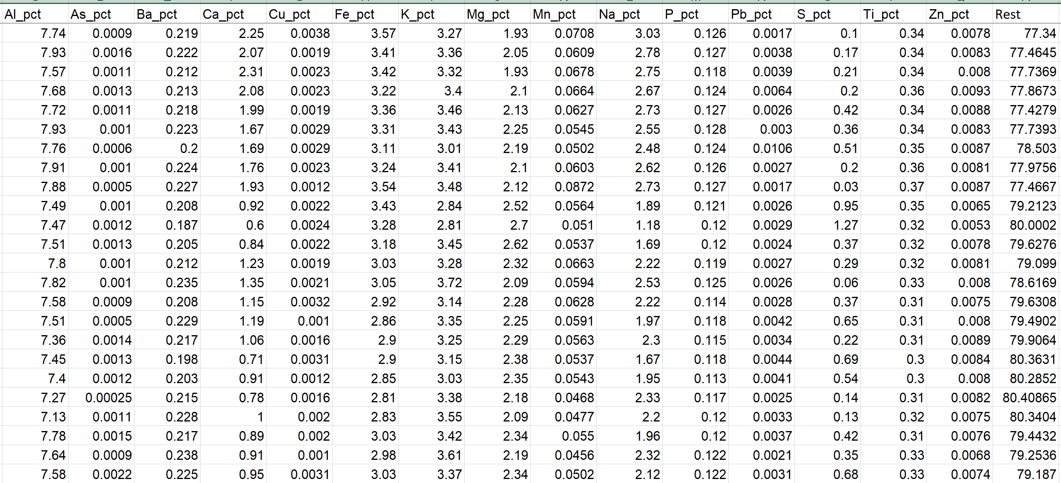
The next step is to set up a matrix of all the mineral species to be considered in the calculation. In the first column are the mineral names. The second column is the Gibbs Free energy per unit mass of mineral at the average estimated temperature for the hydrothermal system. The subsequent columns are all of the assay fields entered as the data for the calculation. Each mineral species is then converted to percent values of each of the elements. All of the other elements in the mineral that were not analysed (Si, O, H2O, CO2) are included under “Other”.
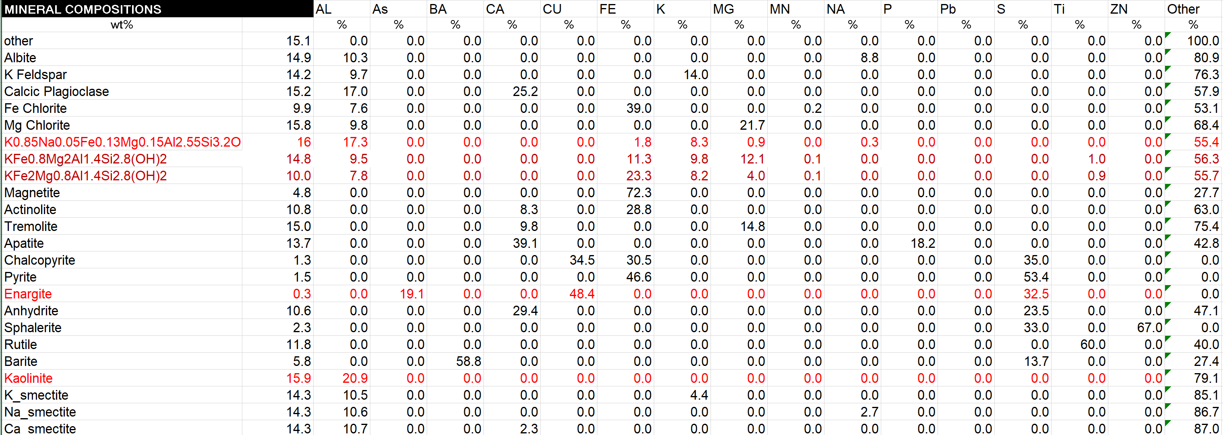
The Solver algorithm works in a way to calculate percentages of minerals such that the sum of each element in each mineral matches the whole rock analysis for that element. That is, the aim is to have a residual of zero for every element. There is will multiple possible solutions for this since there are more variables than constraints. Solver will find the solution that maximises the value in cell D5. This is the maximum Gibbs Free energy result. The Gibbs Free energy values are effectively a probability factor. If the calculations give a result that does not match the observed mineralogy, then the Gibbs values for a particular mineral can be adjusted up or down until a plausible solution is found.
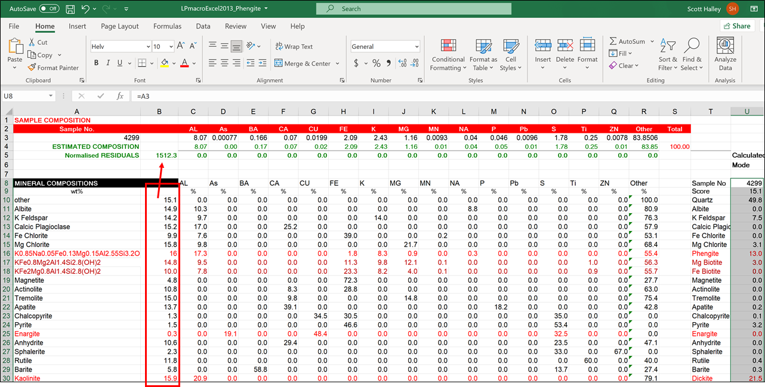
A limitation with this is how to deal with solid solutions. For the feldspars, pure endmembers for K, Na and Ca feldspar were used. The same can also be done for alunite. However in chlorite, biotite and white mica, there are common solid solutions of Mg and Fe, and also Si + (Fe,Mg) Al(tet) + Al(oct). Solid solution variations in white mica, black mica, chlorite and amphiboles significantly influence the mass balance calculations. The error bars can be significantly reduced if real solid solution analyses of these minerals are used in the calculations. Even better is to divide the data into subsets based on predicted groups of median solid solution compositions.
A macro within the program calculates a solution for each sample, writes the result to an Answers table and then advances to the next Sample_ID.
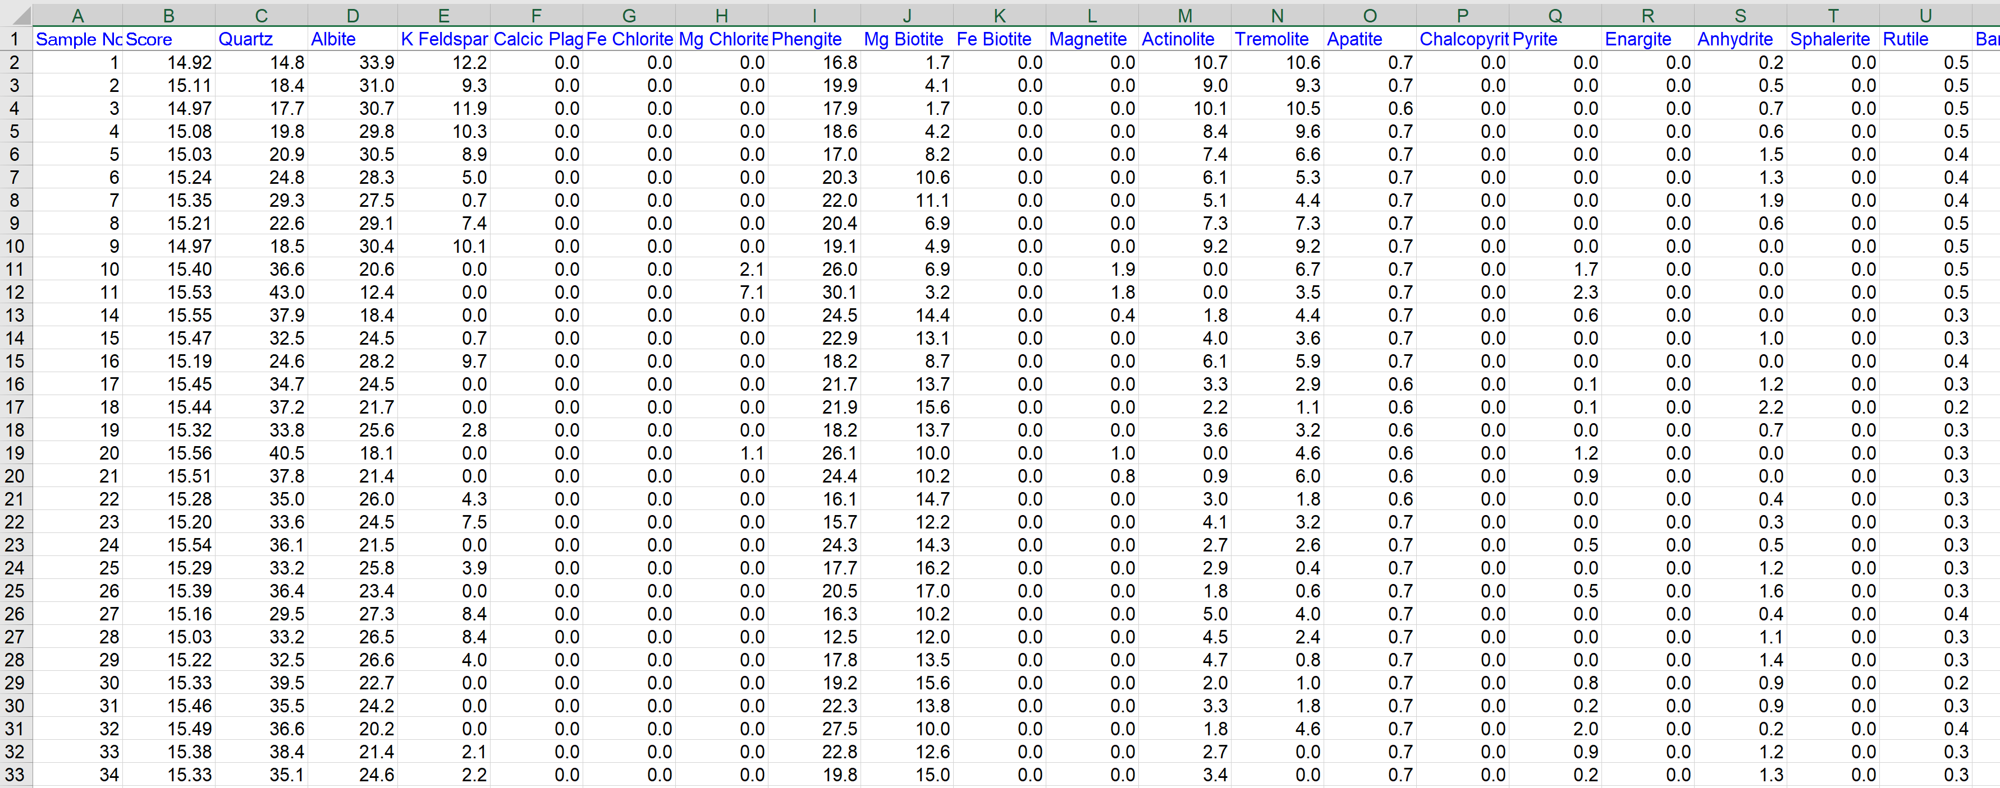
An independent quantitative mineralogy method on a selected subset of samples is required to test the results. However, the calculated mineral percentages can be plotted on the standard alteration diagrams from the whole rock chemistry to at least test if the calculated results are plausible. The 3 plots I would use to do this are;
- K/Al versus Na/Al molar ratio plot
- Al-K-Mg ternary
- Ca-Fe-S ternary
The data used in Exercises 2 and 3 was run through the CODES Calculated Mineralogy program. The Advanced argillic samples plus samples with intense phyllic alteration were calculated in one spreadsheet using a muscovitic mica composition and including alunite. All of the other samples were calculated using a phengitic mica composition and without alunite.
Open the Calculated Mineralogy ioGAS file. The K/Al versus Na/Al molar ratio plot, Al-K-Mg ternary and Ca-Fe-S ternary are already created. Two different checkpoints have already been saved. One showing the interpretation of Mineralogy from Assays, and the other showing Mineralogy interpretation from SWIR (Corescan). Go to Home, Open Checkpoint, Select the checkpoint, Restore. This will revert to those previous classification schemes.
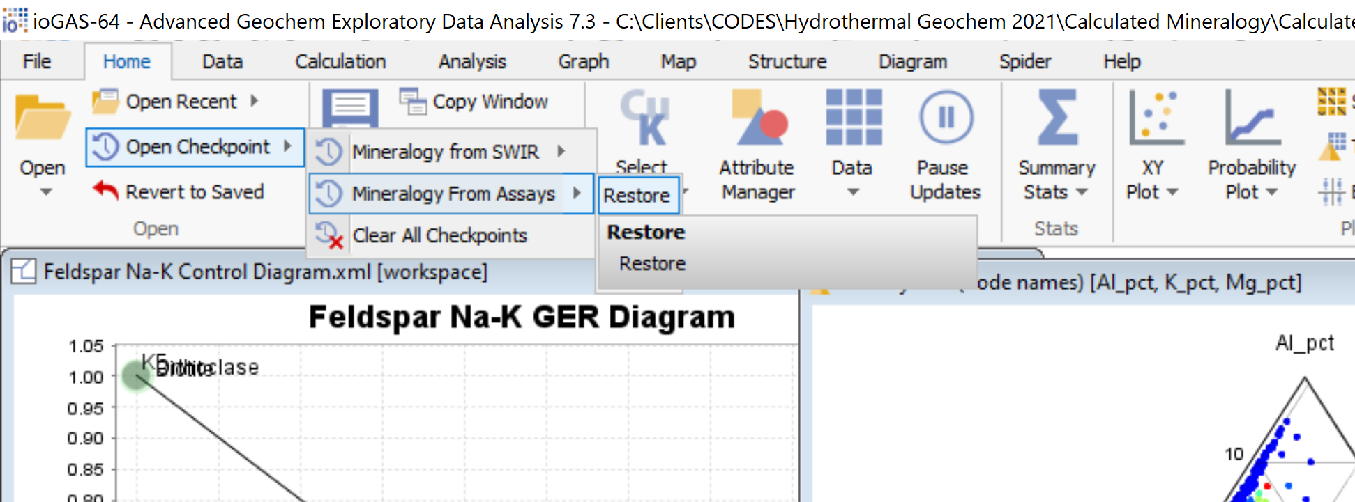
To test whether the Calculated Mineralogy results are plausible, go to the Attribute Manager. In the bottom left corner with the drop-down arrow, select one of the Calculated Mineralogy fields, eg, Sericite. Pick 10 equal ranges, a linear colour stretch, then click Auto-Attribute. The 3 alteration plots will then be coloured by the percentage of white mica. On the K/Al versus Na/Al molar ratio plot, note how the sericite percentages plot relative to the Muscovite Node.
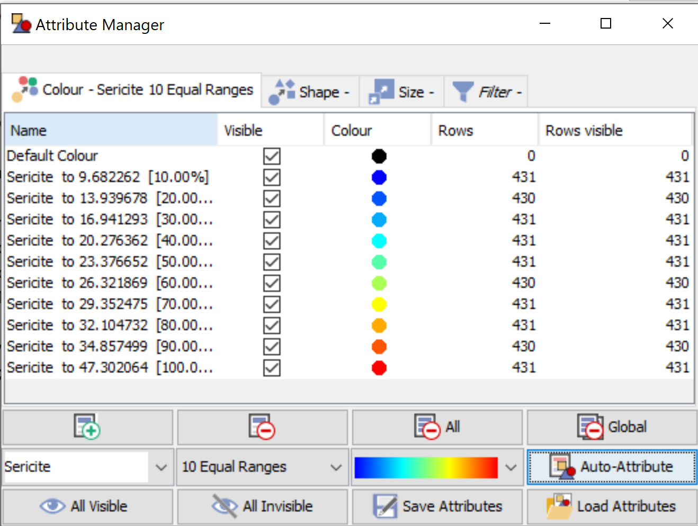

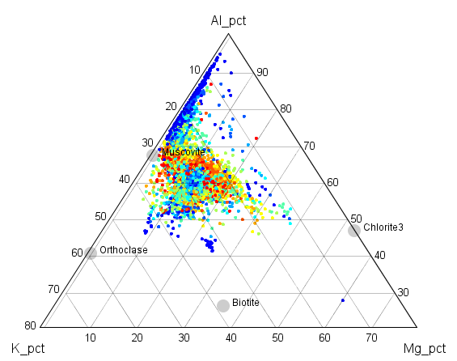
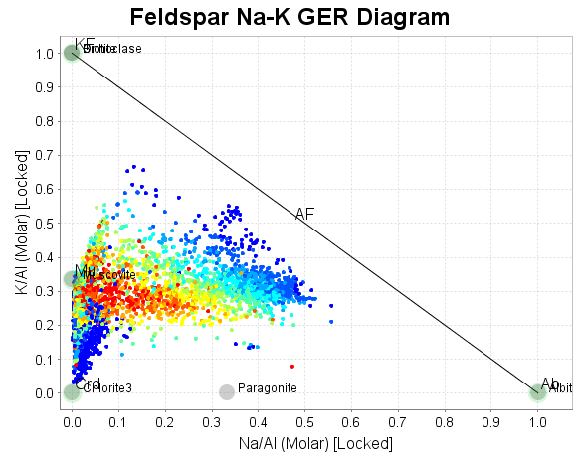

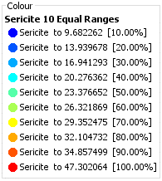
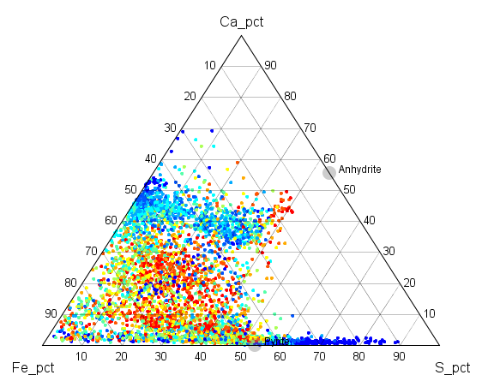
Note the spatial distribution of Sericite% on the Cross section.
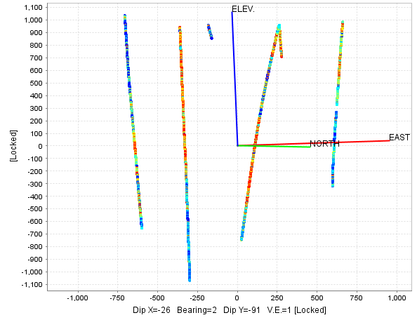

Repeat this process to create 10 equal colour ranges of
- Sericite
- Pyrite,
- Anhydrite,
- Biotite,
- Chlorite,
- Amphibole,
- Quartz,
- Aluminosilicate (advanced argillic minerals),
- Alunite.

References.
Herrmann, W. and Berry, R.F., 2002. MINSQ–a least squares spreadsheet method for calculating mineral proportions from whole rock major element analyses. Geochemistry: Exploration, Environment, Analysis, 2(4), pp.361-368.
Berry, R., Hunt, J., and McKnight, S., 2011, Estimating mineralogy in bulk samples: Australasian Institute of Mining and Metallurgy (AusIMM) International Geometallurgy Conference, 1st, Brisbane, Australia, 2011, Proceedings, p. 153–156.
Press, W.H., Flannery, B.P., Teukolsky, S.A., and Vetterling, W.T., 1986, Numerical recipes: The art of scientific computing: Cambridge, Cambridge University Press, 818 p.
Escolme, A., Berry, R.F., Hunt, J., Halley, S. and Potma, W., 2019. Predictive models of mineralogy from whole-rock assay data: Case study from the Productora Cu-Au-Mo deposit, Chile. Economic Geology, 114(8), pp.1513-1542.

