Interpretation of Rock Compositions and Alteration Mineralogy from 4 acid digest ICP Geochemical Analyses

Scott Halley, April 2020

Introduction

For this tutorial, it is advised that you should have first read Halley (2020) to provide a background for the principles that will be applied in the tutorial. It is also assumed that you will have a reasonable working knowledge of the ioGAS software. The idea is that you should use the provided data set, open this in ioGAS and follow the steps outlined in this tutorial.
The data set provided for this tutorial comes from a drilling program that was designed to test a soil geochemistry copper anomaly, targeting for a porphyry copper deposit. The geochemical analyses are ICP-AES/MS results following a 4 acid digest. In addition, a SWIR spectrum was measured from each of the coarse rejects. The SWIR spectra were interpreted by Auspec International using its aiSIRIS method. The SWIR results provided in this table are the standard aiSIRIS format.
As well as the geochemical analyses and SWIR mineralogy, the analyses were run through a program to calculate mineral proportions from the measured weight percent of the elements. The program used for this was a more recent version of the Linear Programming method reported by Escolme et al, 2019. Mineral percentages calculated from this method are non-unique, since there are far more variables than constraints. That is, it is possible to have different mineral assemblages that exactly match the same whole rock composition. Escolme et al used a version of the liear programming method that relied on a quantitative XRD training data set to define the mineral assemblages. In the new version used here, a Gibbs free energy function and a guesstimated temperature was used to calculate a mineral assemblage and proportion that fit the analyses at that temperature. From the mineral proportions and compositions, the SiO2 can be calculated. This is an elegant way to calculate SiO2 from an incomplete assay suite (ie, without SiO2 or LOI).
Since SiO2 is not provided as part of a 4 acid digest suite, we will interpret the data at first without using the SiO2 values.

Part 1. Classifying rock compositions using immobile trace element chemistry

To get the most out of this tutorial I suggest that you open the provided excel file in ioGAS and follow along with the plots described in this text. Launch ioGAS. Open the Tutorial.xls file. In the Column Properties dialogue box, set the East value to E_UTMWGS84Z15N. Set the North value to N_UTMWGS84Z15N. Check that the aliased values have set the correct elements and units. Then click on OK.
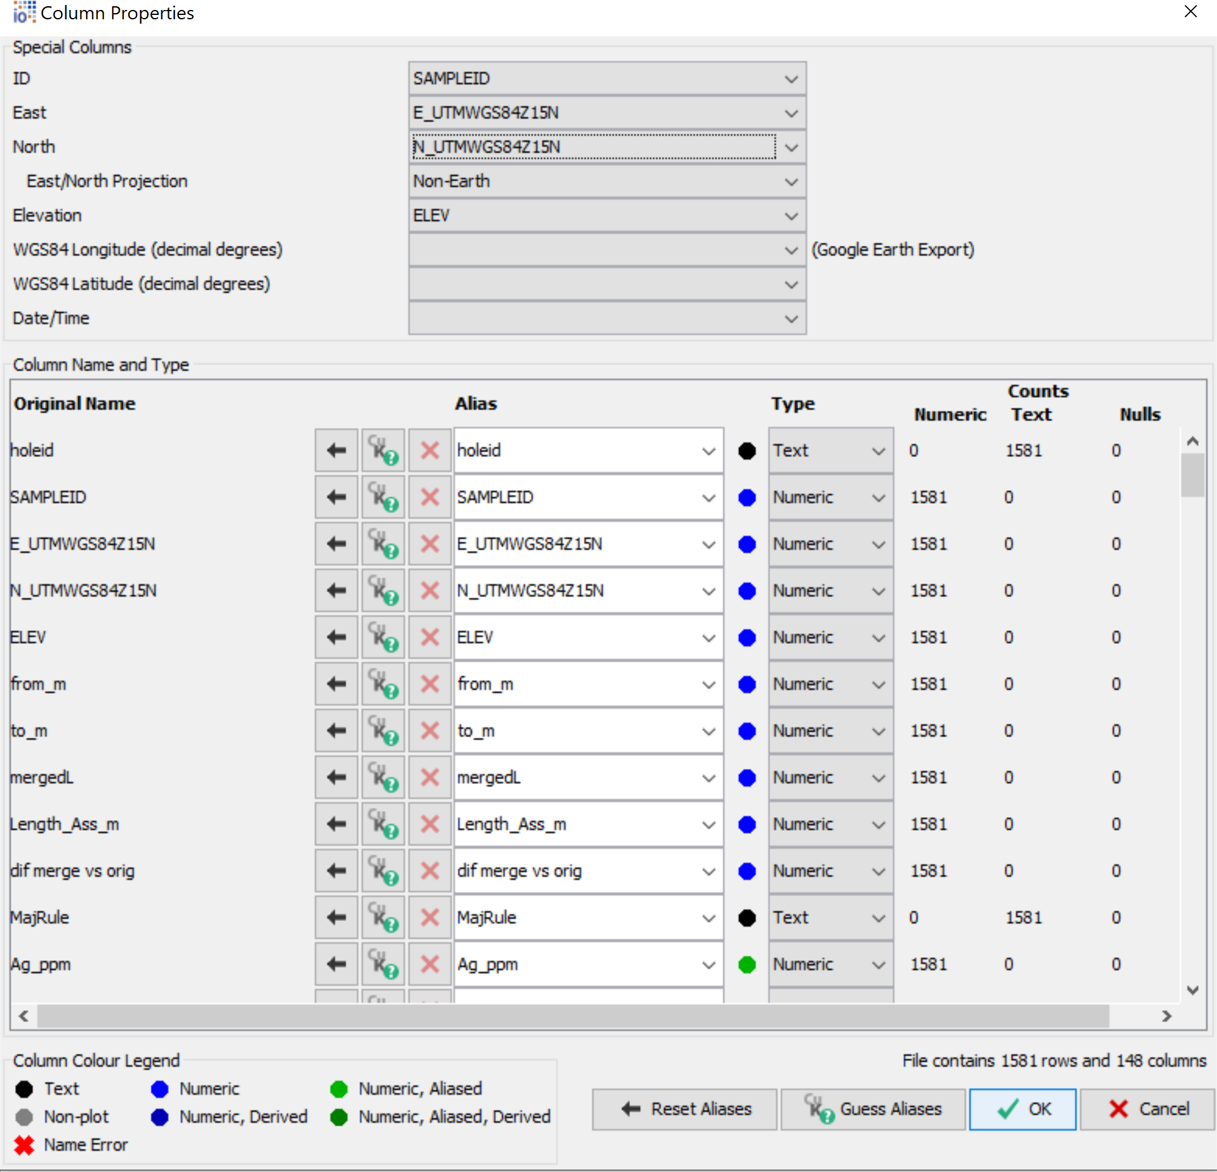

With a 4 acid digest analytical package, I would begin by plotting a suite of high field strength elements against Sc (ie, when we don’t have SiO2, this is the recommended starting point). Select Sc, Th, Ti, V, Zr, P and Nb. Create xY plots, to plot Sc on the Y axis in each plot. At this stage we are just looking for clusters in the data; groups of points that have similar chemical signatures. Much of the data will be ambiguous because there is overlap between the clusters. The recommended approach is to start with the very obvious clusters in the data, apply a colour attribute to those points and then remove them from the plots.

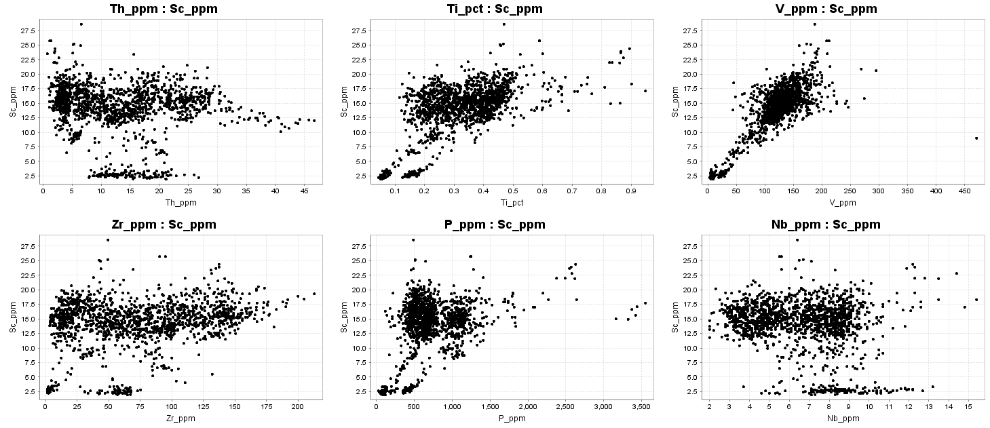
The most obvious groups here are the 2 clusters with very low Sc values. Replot Sc vs Ti to pick these obvious groups.

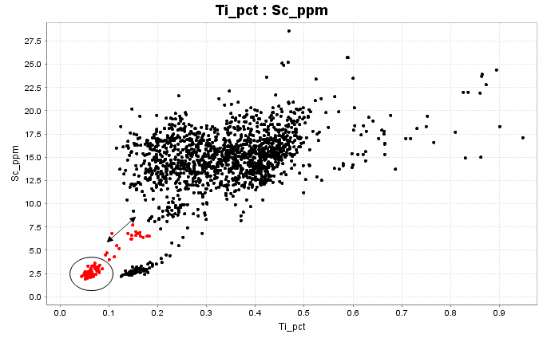
There is a distinct population of points with 2.5ppm Sc and around 0.07% Ti, selected here in red. The trail of points towards higher Sc looks suspicious. These might be samples that were taken to 1 meter intervals rather than geological boundaries, and the tail of points is due to samples taken across a geological boundary. To begin with, I am going to name the colour groups Unit A, B, C, D etc, then compare with the logging codes at the finish.

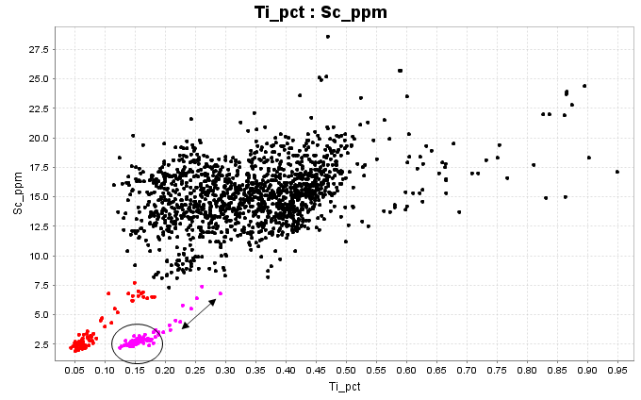
Unit B in magenta also has very low Sc, and a tail of more elevated points which are likely to be sample intervals with mixed lithology.

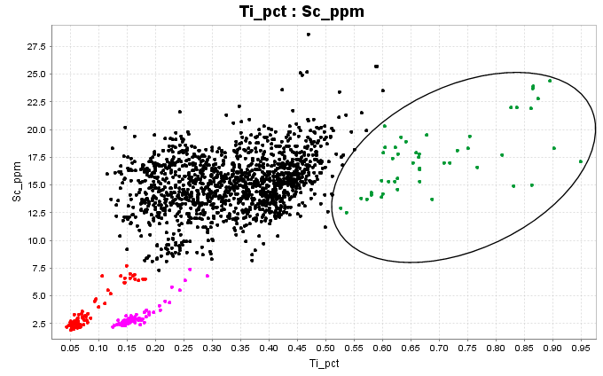
Select Unit C in dark green to include the scatter of points with much higher Ti values. With higher Ti these are likely to be more mafic, but with such a large scatter it doesn’t look like a coherent lithology.
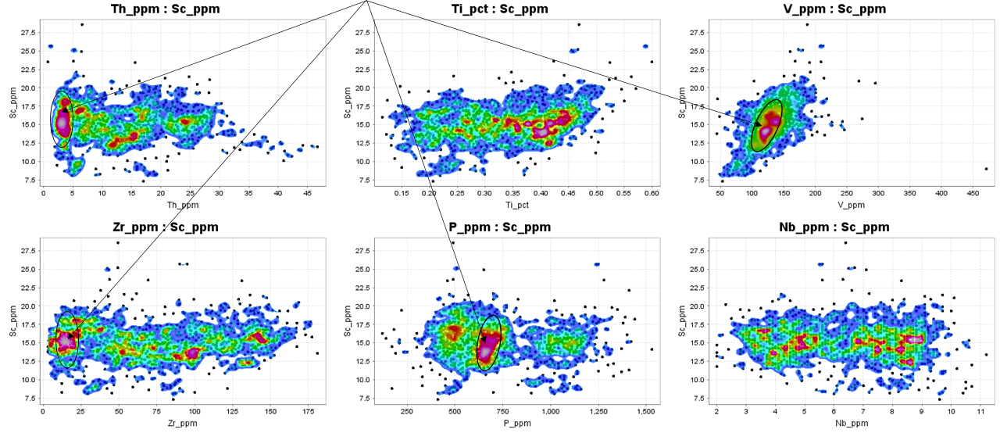
Use the Attribute Manager to turn off Units A, B and C. Go back to the Sc plots and add a point density contour overlay. Look for clusters in the data. Now, there is clearly overlap between the populations, and the classifications become a bit more trial and error. Coherent facies igneous rocks such as lavas or intrusives tend to be compositionally quite homogeneous. The cluster shown in the ellipses looks like a coherent facies. Volcaniclastics commonly have a much wider scatter. Much of the data here looks like volcaniclastics. On the Sc versus P plot, there appears to be a distinct group with higher P. Select this group next as Unit D.
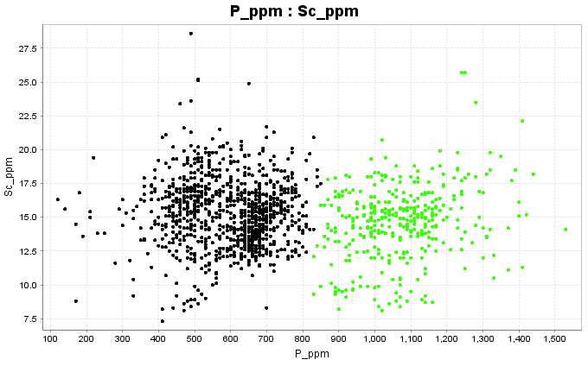

Turn off the green group, (Unit D) and see what remains. Of the remaining points, it looks like Ti is bimodal.
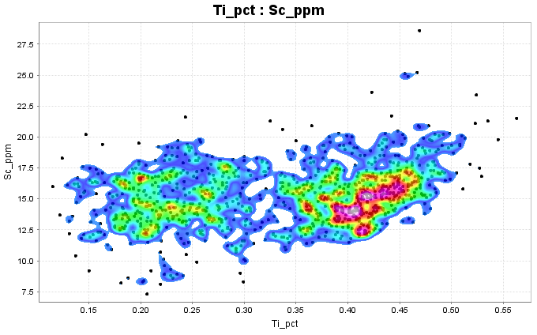

From the Sc versus Ti plot, assign the higher Ti points to Unit E (cyan) and the lower Ti points to Unit F (yellow).
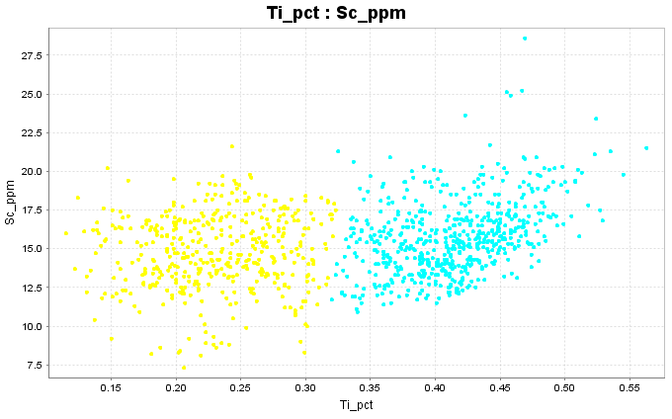

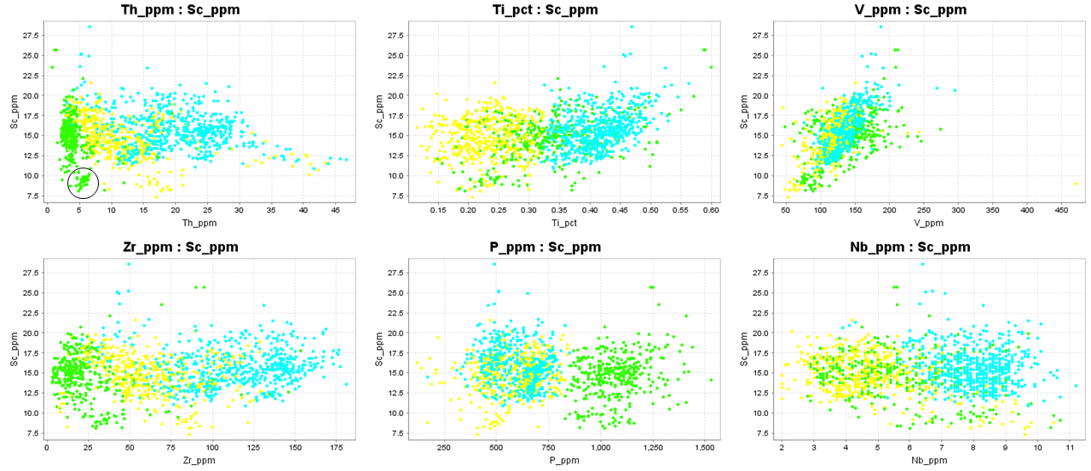
Turn Unit D (green) back on and see how the classification compares with different elements. The yellow and cyan groups were defined from the Ti plot, but the cyan group has higher Ti, Nb, Zr and Th compared to the yellow group. The green group was defined from the high P content, but this is the population that is very tightly clustered on the Sc vs Th and Sc vs Zr plot. Note on the Sc vs Th plot there is a very distinct little subset in the ellipse, with lower Sc. Select these as Unit G.

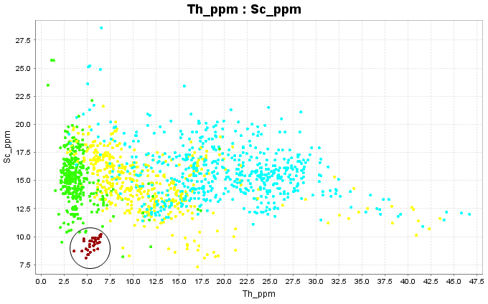

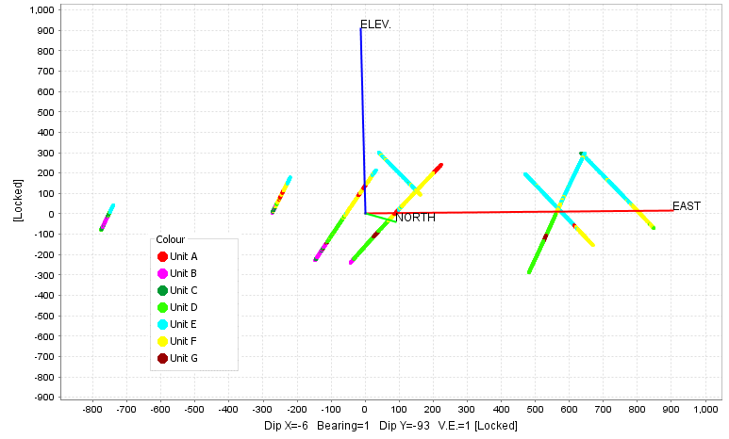
Check to see if the classifications look geologically reasonable; that is plot the points in 3D space to see if the different categories fall into coherent spatial domains.

As a further check on the classifications, I would suggest using the same suite of elements, but plot Ti first, on the Y axis. Notice that on the Ti versus Th plot that some of the yellow group have very high Th and look like they belong with the cyan group. There are also some green points plotting in with the cyan. These should be re-assigned.

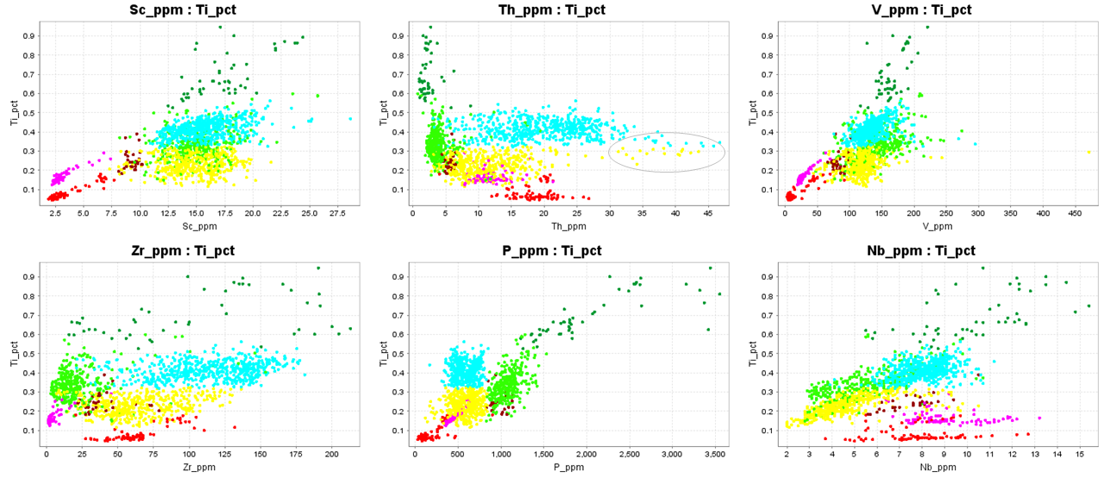

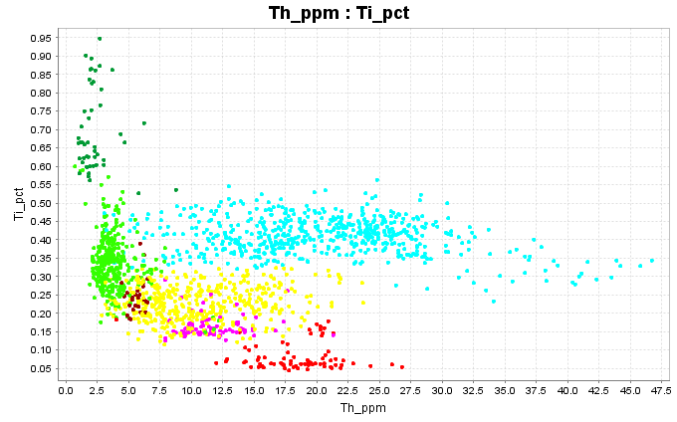
This shows some of the yellow and green points re-assigned into the cyan group.

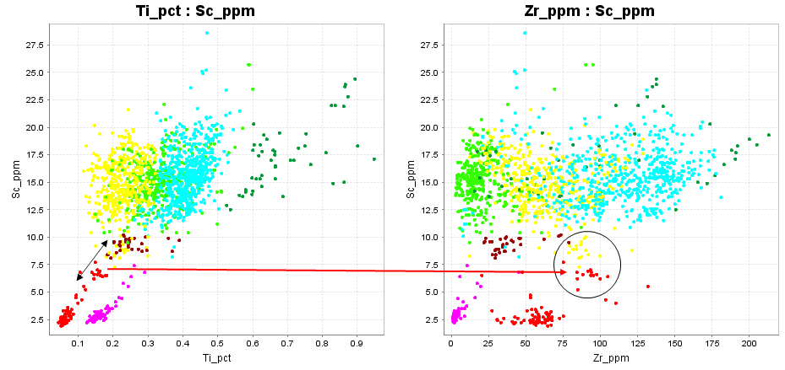
At the beginning, the red points looked like they plotted on a mixing trend on a Sc versus Ti plot. However, note that some of the red points have a higher Zr content, so that mixed sample interval idea must be wrong. Furthermore, those red points with the higher Zr content seem to have more in common with a few outliers of the yellow group. Use a checkpoint in ioGAS. Assign these to a new colour group and see if they group together spatially. These all plot as a continuous string in just one hole.

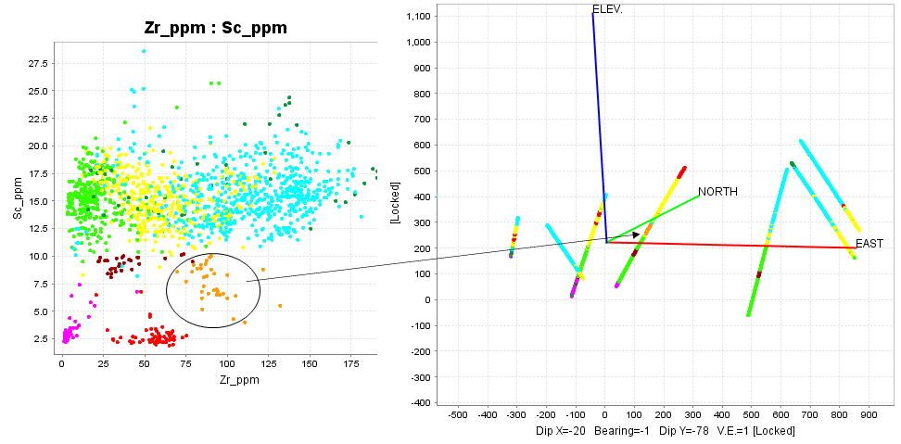
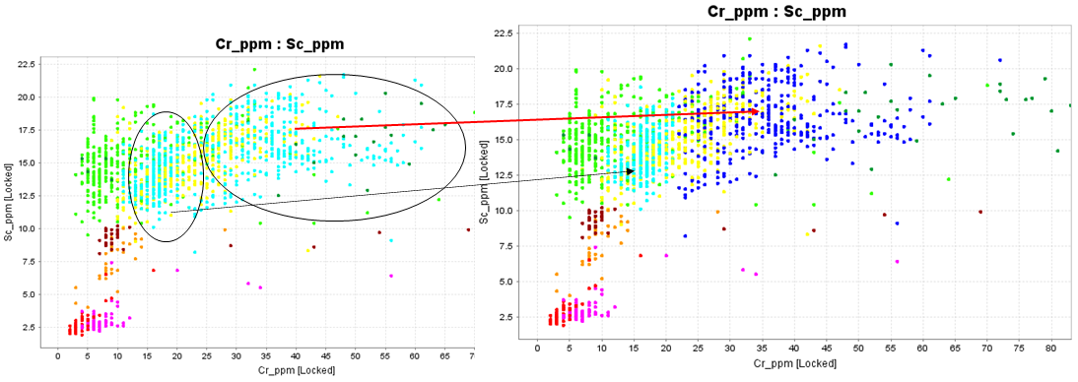
One last thing to check is plot Sc versus Cr. In terms of the Cr content, the cyan group is bimodal. Pick out the high Cr samples from the cyan group and make them dark blue. Then plot these spatially and make sure this classification looks geologically reasonable.
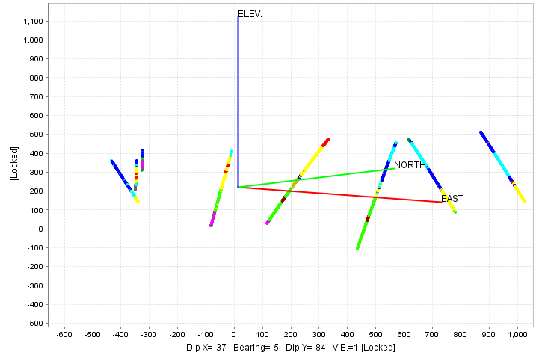

Following through all of the preceding steps, the point I have tried to make here is that there is no right or wrong way to do this. You need to keep interrogating the data to make the most consistent interpretation.
Another reality check is to plot the chemical classifications against the logging codes. These rocks are strongly altered, and picking lithology is not easy. In this case, it is clear that the chemistry has identified different eruptive events that could not be recognised visually. However, the analyses can only identify compositions, but it says nothing about the texture of the rock. There is no way to distinguish intrusives from lavas, volcaniclastics or even epiclastics. I know from experience that when I attempt to classify rocks just from the analyses, there is always some degree of ambiguity. The result is always improved by integrating the analytical data with visual observations, ie logging. We should be sceptical about statistical methods of data analysis that are independent of human input!

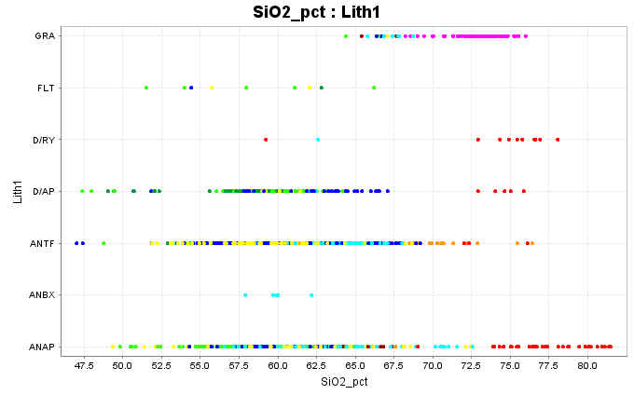

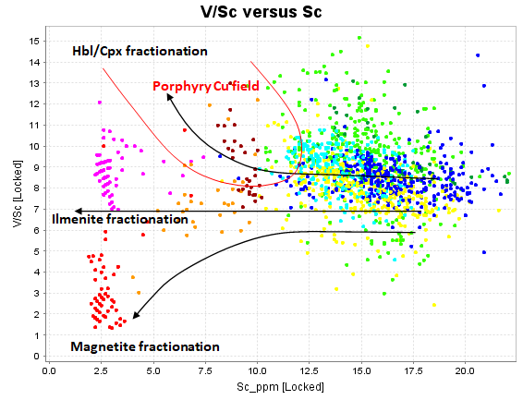
Now that the compositions have been classified, consider what these compositions mean. Use the New the Calculation function in ioGAS to calculate V/Sc ratio. Plot V/Sc versus Sc. This is the proxy for the Bob Loucks V/Sc versus SiO2 plot when you don’t have analyses for SiO2. Both V and Sc are compatible elements, so their abundance in rocks decreases with increasing SiO2. However these elements will favour different minerals depending on the oxidation state and water content of the melt. In reduced magmas (ie ilmenite series), Vanadium has chemical properties very similar to Sc and with very similar partition coefficients, so the ratio remains the same at around 7 with decreasing Sc content. In more oxidized conditions, vanadium prefers magnetite, while Sc still prefers Fe silicates. Therefore in melts that fractionate magnetite before Fe silicates, the V/Sc ratio decreases with differentiation. All magnetite-series crustal melts do this. Magmas that are prospective for porphyry Cu’s are unusual in that they fractionate a low of Fe-silicates before magnetite. Sc is compatible with the Fe silicates, but V4+ is relatively incompatible, so these melts tend to higher V/Sc ratios. The points in red show strong fractional crystallization of magnetite. The rest of these rocks have average V/Sc ratios around 8, but still have high Sc (ie low SiO₂) and do not show evidence of hornblende fractionation. The same plot is repeated below using the estimated SiO₂ value.
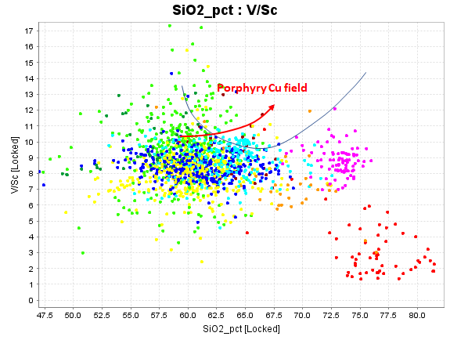

For the next plot, we are going to use a pre-packaged ioGAS plot. Go to Diagrams, Porphyry Cu Exploration, Adakites, Sr/Y vs Y.
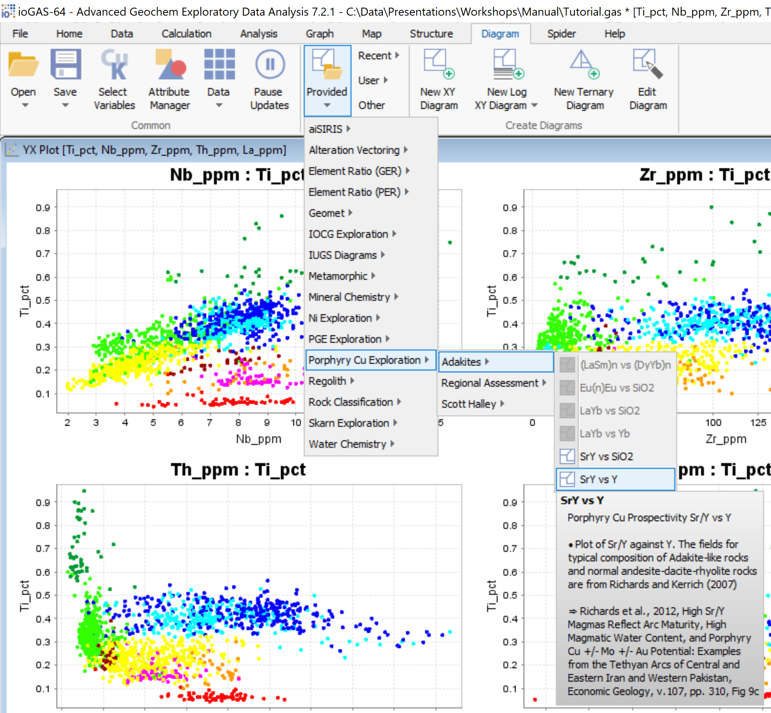
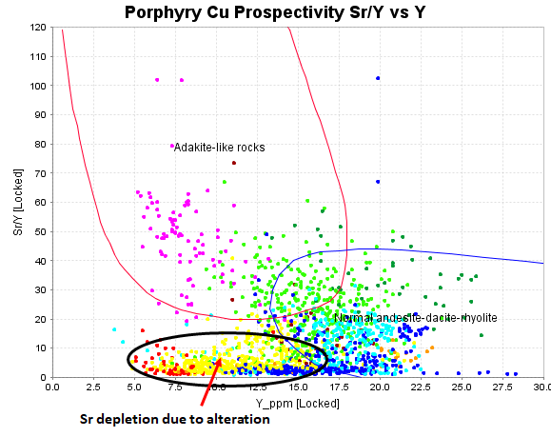
On this figure, most porphyry Cu magmas would plot at around 10ppm Y and Sr/Y around 40 to 100. High Sr is an indicator of high water content in a melt, which acts to depress the solidus, hence reduce the amount of plagioclase (especially sodic plag). Y is depleted in melts particularly by retention of HREE’s in garnet in the source region of the melt. The magenta points plot in the porphyry copper space on this plot BUT are not enriched in V relative to Sc. The green points are on a favourable trend, but are not sufficiently fractionated.
Porphyry Cu magmas typically have low levels of High Field Strength Elements. In most magma types the HFSE’s are incompatible, therefore become progressively enriched with fractionation. However that does not happen in porphyry Cu magmas, since these elements are readily accommodated in titanite. Titanite fractionation in porphyry Cu magmas removes HFSE’s from the melt and they remain consistently low with fractionation.
Plot Ti vs Nb, Th, Zr and La as an xY scatterplot. Porphyry magmas typically have around 3000 to 5000ppm Ti, 2 to 4 ppm Nb, 2 to 4ppm Th and quite low La and Zr. Of all the compositions in this data set, it is the pale green group that best fits that description. In addition, these points are very tightly clustered and have a characteristic that looks more like an intrusive rock rather than a (heterogeneous) volcaniclastic.
In summary, none of the compositional groups here have the fractionation signatures of a porphyry copper magma, but the pale green group comes closest, and could be at the more mafic end of the spectrum.

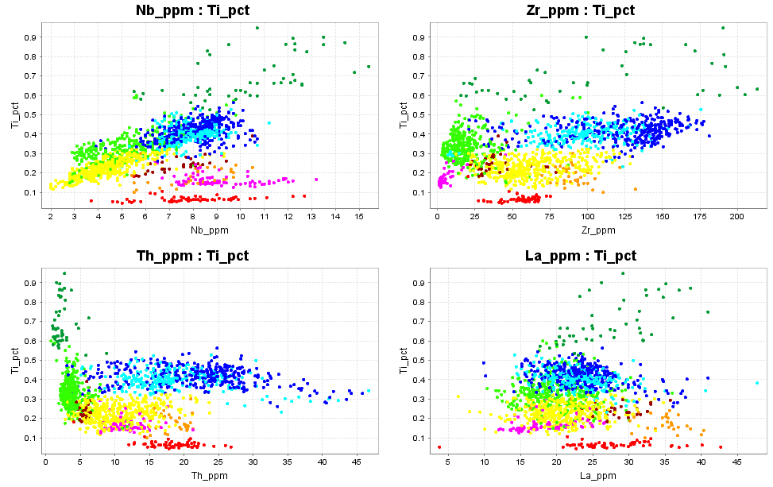

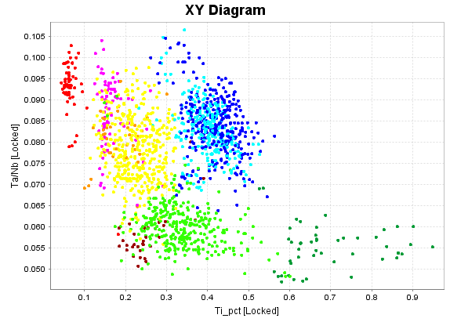

One last diagram worth trying is this; Ta/Nb versus Ti. Magmas that have fractional crystallization of biotite become very depleted in Ti but have a strongly increasing trend of Ta/Nb.The blue and yellow points have a slightly elevated Ta/Nb ratio that probably reflects their source region, and the red points are slightly fractionated.

Part 2. Classifying Alteration from Major Element Plots.

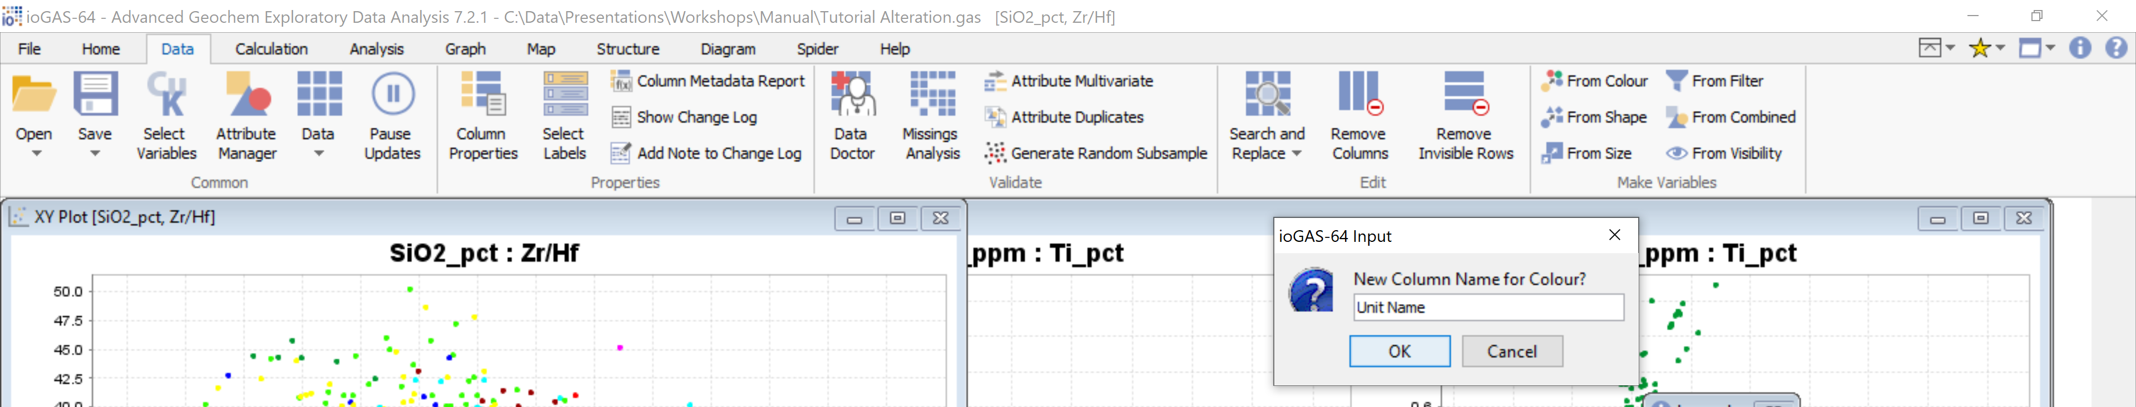
In ioGAS, go to Data, Make Variable from Colour. In the dialogue box, add Unit Name as the column name for the colour group. This will add a column to the ioGAS data file to save the classification of the rock compositions. We can now use a new colour table to describe the alteration.
Save a copy of the ioGAS file and name it Tutorial_Alteration.
Close all windows.
Go to Diagram, Provided, Element Ratio (GER), Feldspar, Feldspar Na-K Control Diagram. This will generate a K/Al versus Na/Al molar ratio plot.
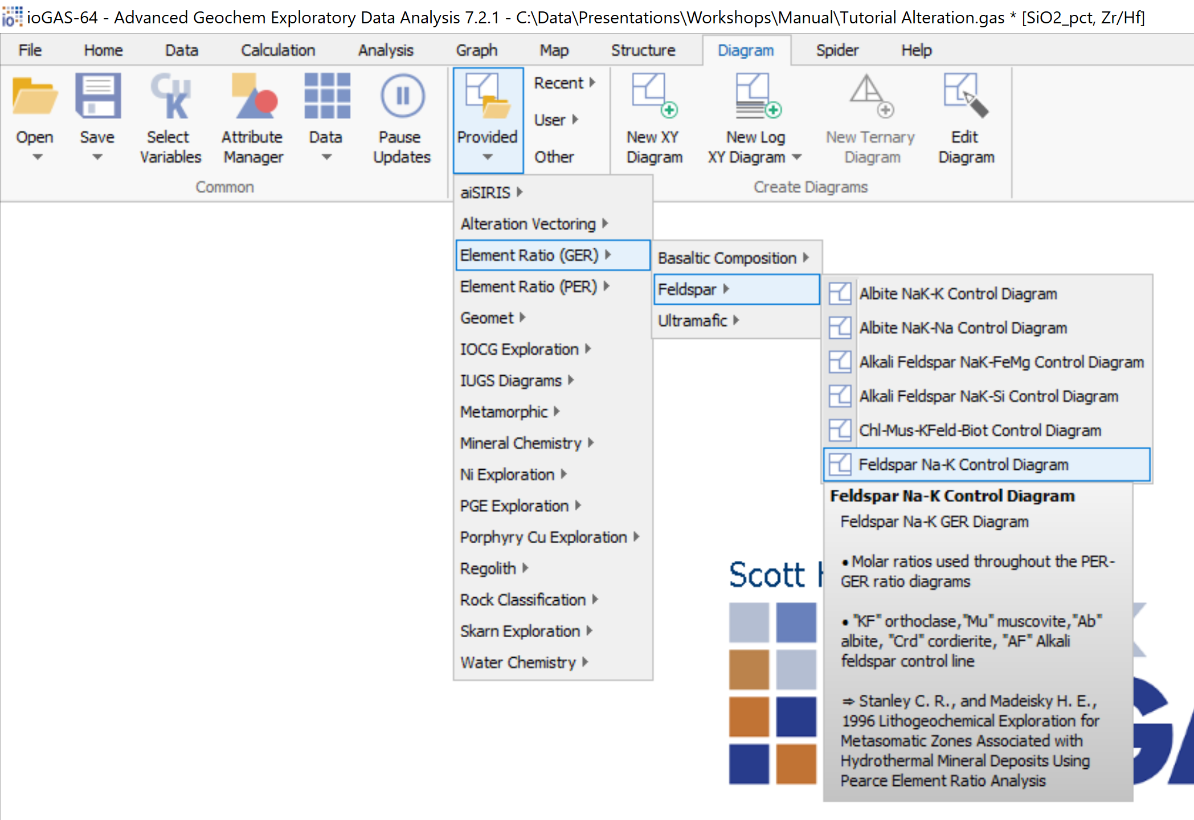

Once you have made the K/Al versus Na/Al molar ratio plot, toggle the Point Density Contour overlay on and off to help visualize where most of the data plots. The magenta group plots as a tight cluster near the node for a typical rhyolite. These rocks are unaltered (this is an intrusive phase that post-dates hydrothermal activity). The points that plot near the nodes for typical dacite, andesite and basalt are also relatively unaltered. The vast majority of these samples are strongly Na-depleted. There is a trend of points heading away from the expected least-altered compositions becoming progressively more Na-depleted, but the trend is not towards the muscovite node as would be the case in typical phyllic alteration. The trend is towards a combination of white mica plus another aluminosilicate phase. From this plot it is impossible to tell what the other phyllosilicate is. It could be chlorite, kaolinite, dickite, etc. The way to test this is to create another plot which includes Mg. I suggest a ternary plot of Al-K-Mg.
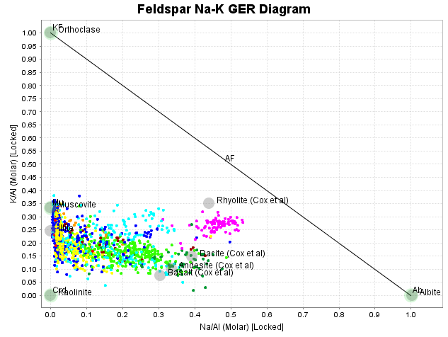
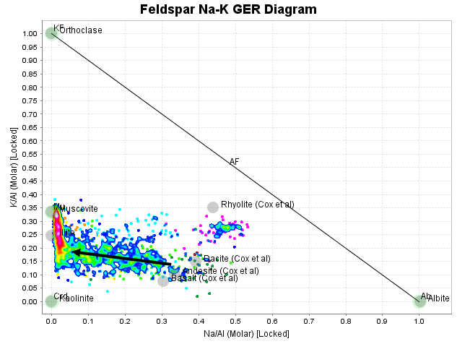

In the Al-K-Mg ternary plot, advanced argillic alteration (AA) would be Mg-depleted, and plot on the Al-K edge of the ternary between the muscovite node and the Al apex. These data do NOT have AA alteration. Most of the data plot near the join between muscovite and chlorite. Most of the samples have K/Al molar ratios less than 0.33 (muscovite) because much of the Al is hosted in chlorite.
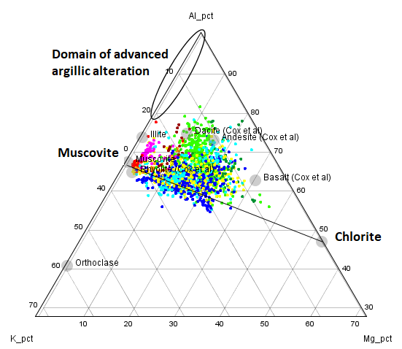

In most of these samples plagioclase has been destroyed by hydrothermal alteration, resulting in the removal of sodium. What has happened to the Ca? To investigate this, create a Ca-K-Na ternary plot.
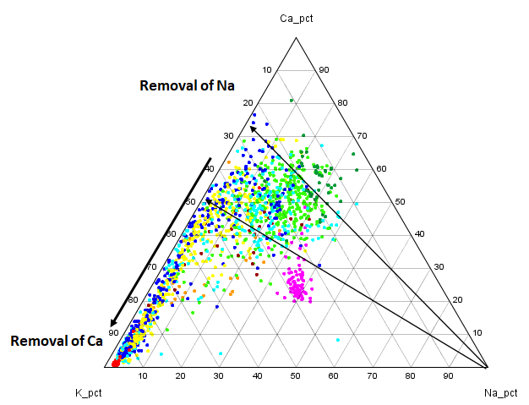
This plot shows that as sodium was removed via hydrothermal reactions that altered plagioclase, the data points shifted directly away from the Na apex until they reached the K-Ca edge of the ternary, From there, continuing alteration removed Ca until compositions arrived at the K apex. In other words, initial reactions resulted in the destruction of plagioclase, but retention of Ca either as a sulfate or as a carbonate.
To test whether the Ca phase in the altered rocks is carbonate or sulfate, create a Ca-Fe-S ternary plot. On this plot it can be seen that the rocks react until they reach the tie-line between pyrite and calcite, and then Ca-removal progresses until compositions reach the pyrite node. The reaction trends do not head towards anhydrite.
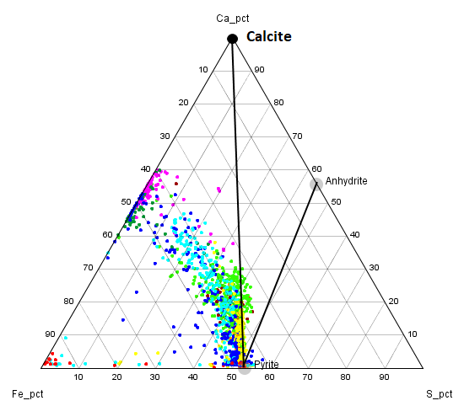

Based on the diagrams and discussions above, the data can be assigned to alteration categories. Delete all the colour groups that were assigned to the rock compositions. We will make a new set of colour groupings to describe the alteration mineralogy.

From the K/Al vs Na/Al molar ratio plots, create a new colour group (grey). Within this group, select the samples that are least-depleted in Na, plotting near the nodes for type examples of rhyolite, dacite, andesite, basalt. Create a second new colour group (cyan) and select the samples containing relict albite. These samples most likely have albite-sericite-chlorite and carbonate. At this point the samples that are strongly Na-depleted will still be the default colour (black). Use the point density contour overlay to help you decide where to put the boundaries.
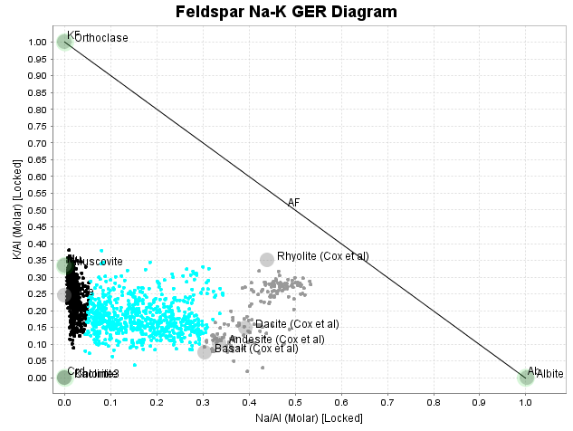

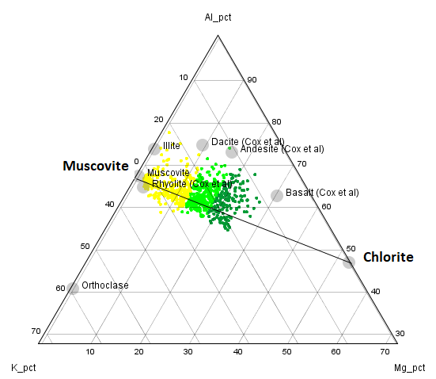
On the Al-K-Mg ternary plot, turn off the background and relict albite groups. The remaining points are all strongly Na-depleted. I have divided these into sericite (yellow), sericite-chlorite (pale green) and chlorite-sericite (dark green) according to where they plot along the muscovite-chlorite join.
On the Ca-K-Na ternary plot, I have used the attribute manager to add a larger point size group. I used this to depict the samples that have lost Ca, ie the low-carbonate samples. The mineralogy interp can now be plotted in the 3D viewer.

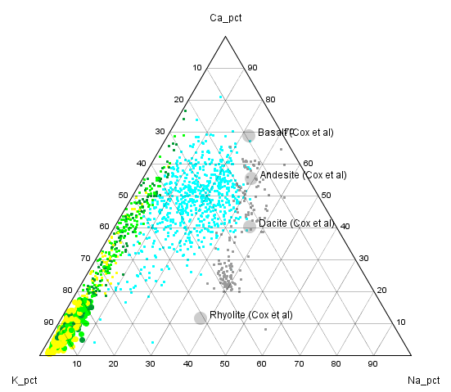
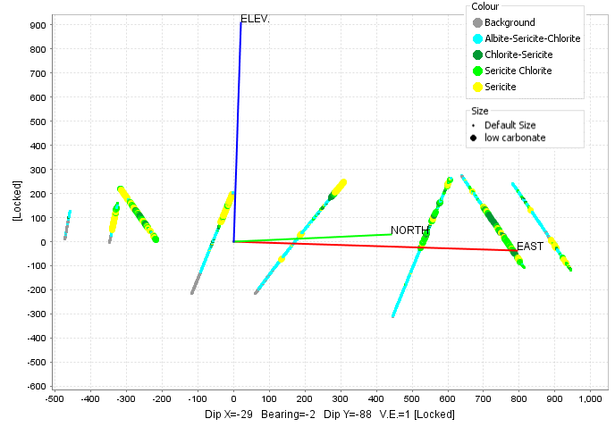

Plot Fe versus S. This shows that most of the available Fe in these rocks has reacted to form pyrite. Those samples that still contain chlorite plot just on the Fe-rich side of the pyrite line (the line where the Fe:S ratio matches the stoichiometry of pyrite)
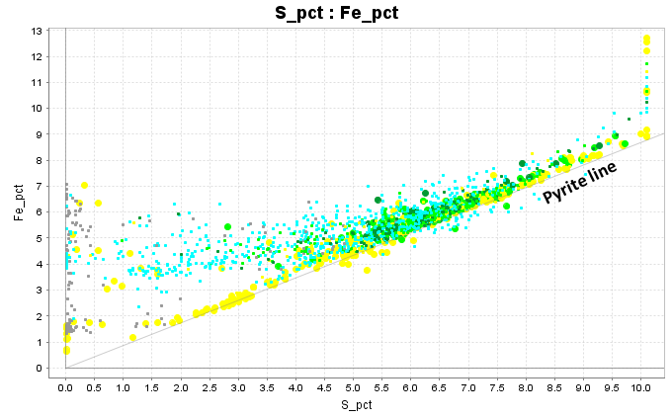

Part 3. Comparison with Calculated mineralogy
Save a copy of the file, or save a checkpoint. During this next stage, we will use the standard alteration plots based on major elements to evaluate how well the calculated mineralogy has worked.
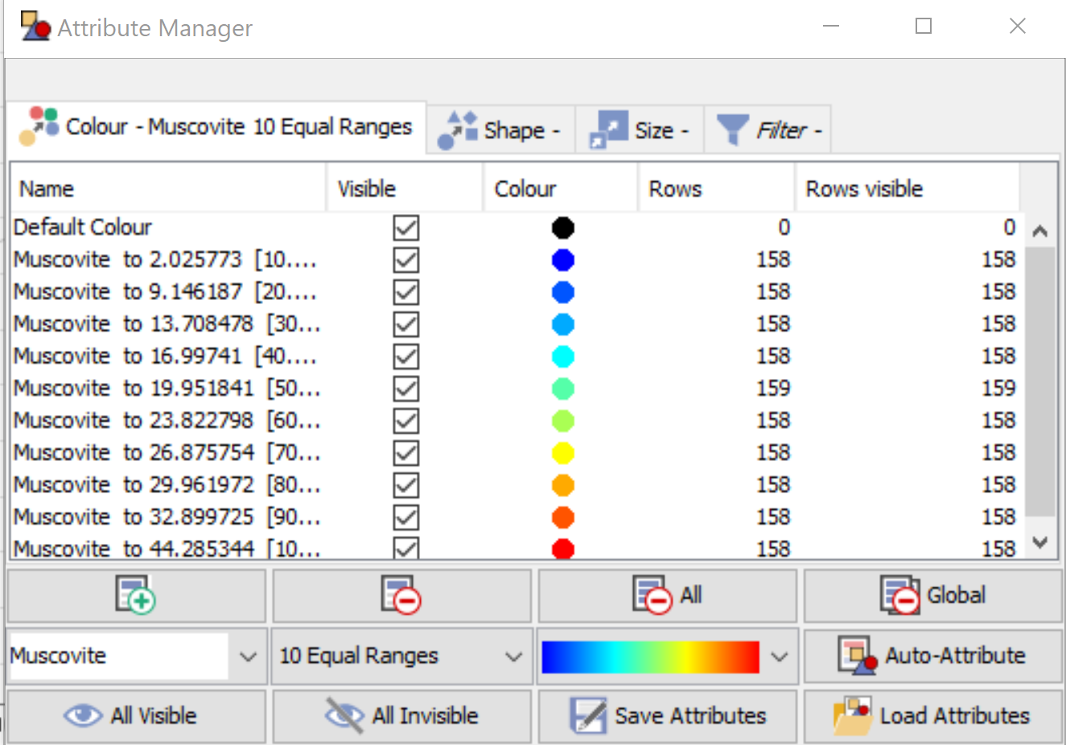
In the Attribute Manager in the bottom left corner, there is an arrow with a drop-down menu. Using this I can select the calculated weight percent of muscovite as the variable. I will use a colour scheme that assigns the Muscovite wt% into 10 bins each with an equal number of samples. I’ll select a rainbow colour stretch. Then click on Auto-Attribute. All the data points are now coloured by the relative proportions of muscovite.
Go to the K/Al versus Na/Al molar ratio plot to see how this matches the whole rock chemistry. That looks exactly how we would expect. Have a look in the 3D map plot to see the spatial distribution of sericite.
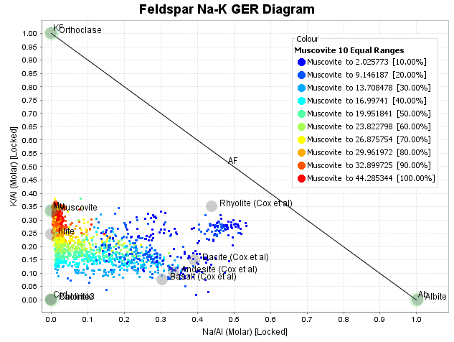
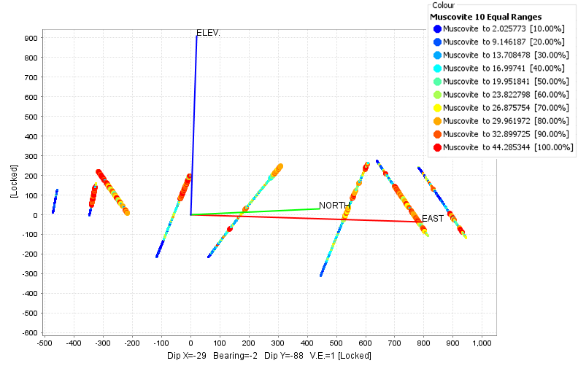

Next, choose the colouring variable as Chlorite. Create 10 equal ranges. Look at the Al-K-Mg ternary plot. Note on this plot that the most chlorite-rich samples plot mid-way between muscovite and chlorite.
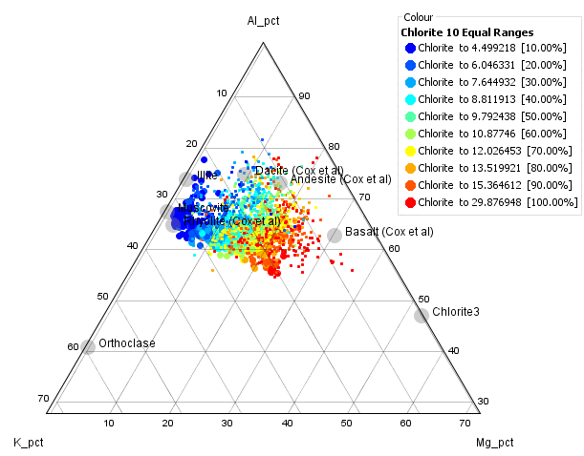

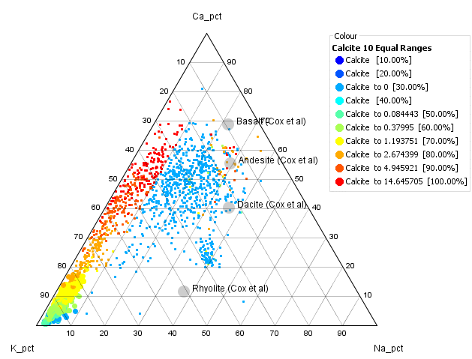
In the attribute manager, color the point by calculated weight percent calcite. Create a Ca-K-Na ternary plot to see where the carbonate-rich samples occur on this plot.

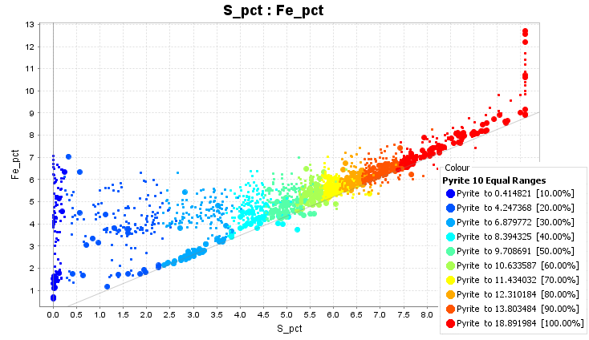
In the attribute manager, color the point by calculated weight percent pyrite. Look at the pyrite percentages on a plot of Fe versus S. The alteration in this system is strongly pyritic!

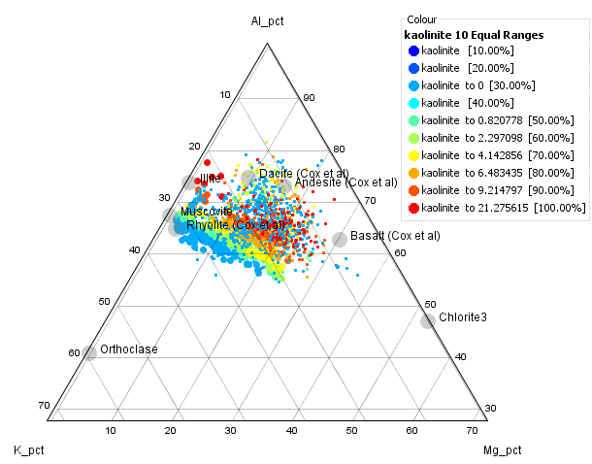
Colour the data by 10 equal ranges of calculated Kaolinite%. This is an unexpected result. In this case, kaolinite occurs in an assemblage of kaolinite-carbonate-chlorite-pyrite. In most kaolinitic alteration environments, Mg is removed from the rock.
Kaolinite forms at relatively low temperatures. We would expect to see it in systems at less than 200ºC. Low temperature alteration environments have distinctive pathfinder signatures. The most distinctive signature is enrichments in Cs, Li and Sb. Cs is an incompatible element in hydrothermal environments because it is very soluble, but is an unusually large cation and does not easily fit into the lattice of most phyllosilicates. The usual host for Cs is in the disordered structure of smectite or interlayered illite-smectite. Li is an unusually small cation, and therefore has a high ionic field strength. It is accommodated in kaolinite, dickite or interlayered chlorite-smectite. Sb substitutes into the lattice of pyrite, but only at low temperatures.
A really useful way to look at the relationship between mineralogy and particular pathfinder elements is using probability plots.
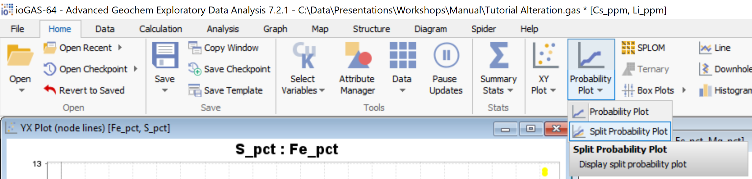
With the data points coloured by 10 equal ranges of calculated Kaolinite%, select Cs and Li as the plotting variables. Go to Home, Probability Plot, Split Probability Plot. On the right-hand tool bar, the Change Distribution button can be used to toggle between Probability Plots and Cumulative frequency plots. The latter are more intuitive; these plot the data as percentile values on the x axis.
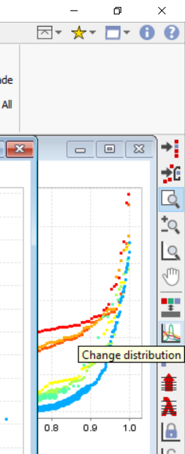
With the data coloured as 10 equal ranges of Kaolinite%, it is very obvious that the kaolinite-rich rocks are highly enriched in Cs and Li.
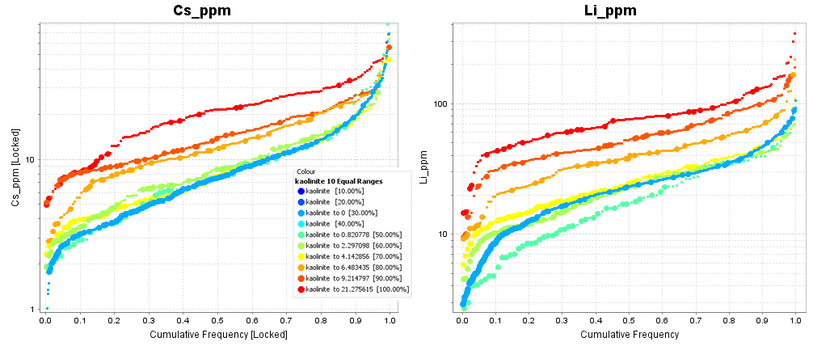

Take some time to experiment with the relationship between pathfinder elements and mineralogy. You can create split probability plots of the pathfinders colored by alteration mineralogy to see which elements are associated with which silicate minerals. Don’t forget to look at the spatial distribution of the metals. Cu and Zn in particular show a very distinct spatial zonation. It is interesting that the lowest temperature alteration (kaolinite-carbonate-chlorite-pyrite), along with elevated Cs-Li-Sb, does not occur furthest outboard in this system. This suggests that it is an overprinting event.
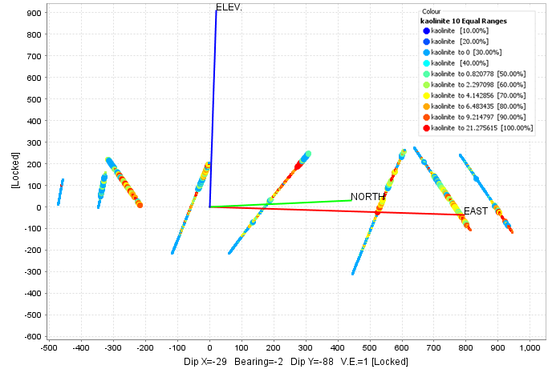

Part 4. Comparison between Mineralogy interpreted from assays and SWIR.

One of the commercial analytical laboratories provides a service where they measure a SWIR spectrum on the coarse rejects using a TerraSpec instrument. Effectively, this provides the average SWIR signature of all the phyllosilicates within the assay interval. The spectra are interpreted by Auspec International using its aiSIRIS™ automated spectral interpretation. The results are reported as the percentage “Spectral Contribution” of a range of minerals. Some phyllosilicates are more sensitive to SWIR than others, so the spectral contribution is not quantitative. There are also some minerals that do not absorb light in the SWIR range. It is very useful to merge the SWIR data with ICP analyses since the ICP data is more quantitative, but the SWIR will be more diagnostic as to which mineral phases are present as well as showing the solid solution chemistry of white mica and chlorite in particular.
With the aiSIRIS data, I like to begin by creating probability plots of the minerals identified from the spectra just so we can see which minerals are most abundant. Use the ioGAS file in which you have coloured the alteration groups. As the plotting variables, choose all of the Mineral_sc values. Create probability plots for these minerals. Toggle to Cumulative frequency plots.
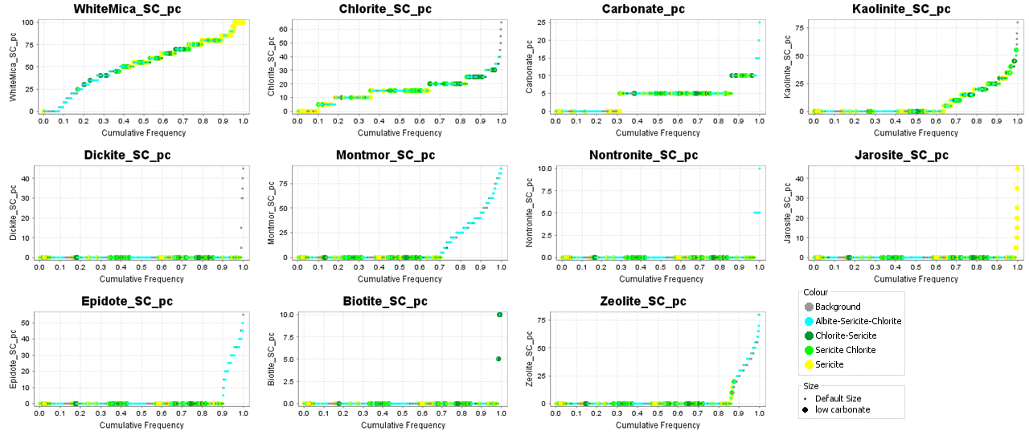
The really abundant minerals identified from SWIR and White Mica, Chlorite, Kaolinite, Montmorillonite and carbonate.
Plot the calculated abundance of Muscovite against the white_mica_sc to see how quantitative the spectral contribution is. I have added a point density contour overlay to the plot to make this more obvious. Where the white_mica_sc is getting up to 80%, in this case the weight% of white mica is around 30%.

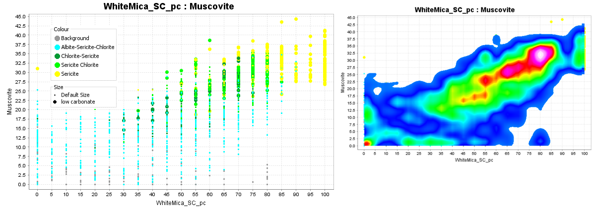
Try similar plots with chlorite, kaolinite and carbonate. Carbonate minerals are weak infrared absorbers and the carbonate absorption features overlap in the SWIR spectrum with chlorite. The fact that the aiSIRIS algorithms pick this at all shows how good their processing is.
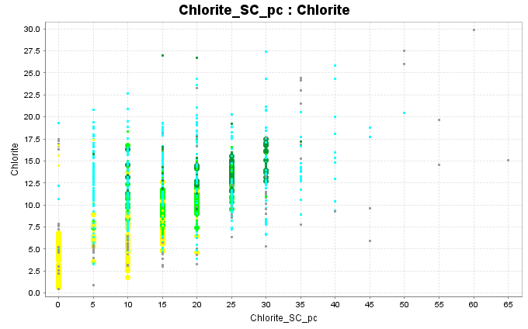
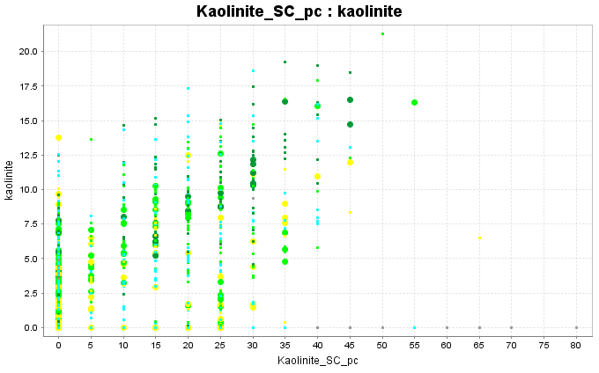
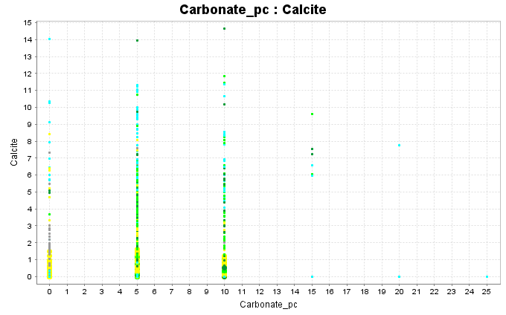
One really useful piece of information derived from SWIR that cannot be obtained from chemical analyses is the solid solution chemistry of mica and chlorite. In white mica there is a coupled substitution of Al for Si in a tetrahedral site, along with Fe or Mg for Al in an octahedral site; eg
(Fe, Mg)^{oct} + Si^{tet} Al^{oct} + Al^{tet}
Sericite with low Fe,Mg are close to the stoichiometric formula of muscovite and have an Al-OH wavelength close to 2195nm. These form at the acid end of the mica stability field. As more Fe,Mg substitutes into the lattice, the Al-OH wavelengths shift to higher values. These will be white micas that have formed in equilibrium with relict feldspar or new hydrothermal feldspar. In effect, the Al-OH wavelength is an indicator of pH. Look at the K/Al versus Na/Al molar ratio plot and colour the data points by the white mica wavelengths. Note how the short to long wavelength values are spread across this diagram. Also look at the 3D spatial distribution of the wavelengths. Note that I have zoomed in on this figure for clarity.
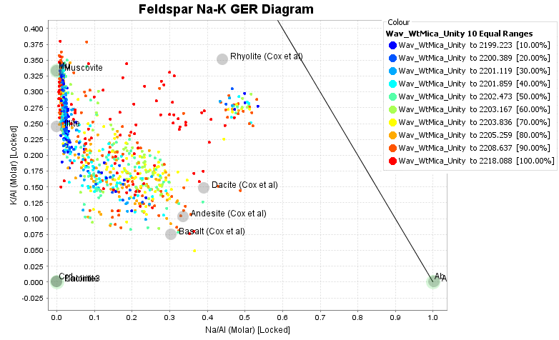
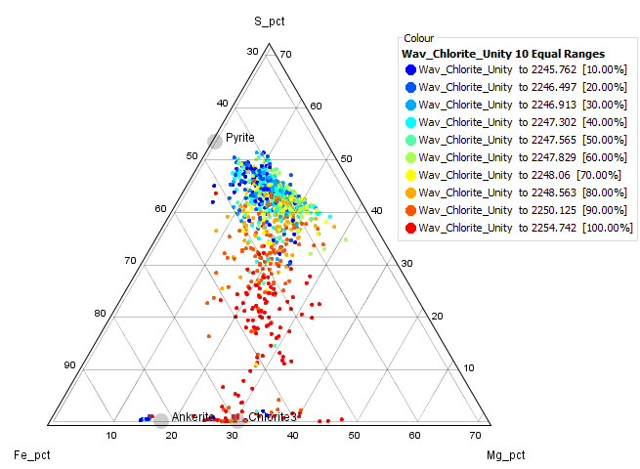
Create a S-Fe-Mg ternary plot. Colour the data points by the wavelength of the chlorite Fe-OH absorption feature. Mg-rich chlorites tend to shorter wavelengths. Fe-rich chlorites tend to longer wavelengths. This plot demonstrated that as more of the Fe is taken up in pyrite, the remaining chlorite becomes more Mg-rich (not surprising).

Create a histogram of the white mica crystallinity index. This numeric value derived from the SWIR data is a ratio of the depth of the Al-OH absorption feature over the depth of the 1900 water feature. Where the K/Al versus Na/Al plot indicates strong sericite alteration, the micas have a high crystallinity index. That is, these are relatively high temperature white micas. Where the rocks are weakly altered and contain relict feldspars, the micas have a low crystallinity index. As described before, these look like a low temperature argillic overprint. Rocks that have previously been affected by an acid fluid are not susceptible to overprinting, but rocks with relict feldspar are easily hydrolysed.
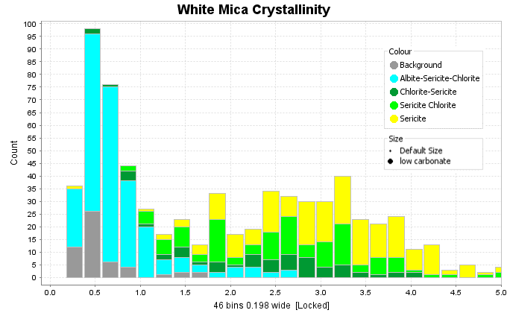
Create 10 equal colour ranges based on the white mica crystallinity index. Make cumulative frequency plots of Cs and Li. This is a very clear indication of how Cs and Li are taken up by the low temperature clay minerals. Elevated Cs, Li and Sb is a classic signature of the outflow from low sulfidation epithermal veins.
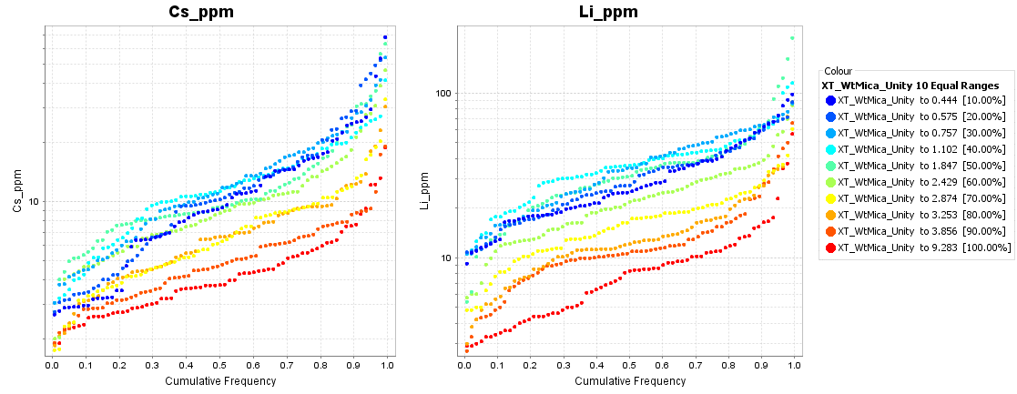

References
Halley, S., 2020. Mapping Magmatic and Hydrothermal Processes from Routine Exploration Geochemical Analyses. Economic Geology.
Escolme, A., Berry, R.F., Hunt, J., Halley, S. and Potma, W., 2019. Predictive Models of Mineralogy from Whole-Rock Assay Data: Case Study from the Productora Cu-Au-Mo Deposit, Chile. Economic Geology, 114(8), pp.1513-1542.

